## Project C: Post-weaning diarrhea I

|  |  |
| --- | --- |
| Name | ID |
| Sarah Elmaasarawii | 202000408 |
| Youmna Tarek | 202001016 |
| Merna Salem | 202000948 |
| Mohamed Elteweay | 202001764 |

**Under the Supervision of:**

**Dr. Mohamed Maysara**

--------------------------------------------------------------------------------------------------------------------------------

**Table of Contents**

## Introduction……………………………………………………………………………………………………………………………….

## Data reading ……………………………………………………………………………………………………………………….

## Descriptive statistics ………………………………………………………………………………………………………………

## Graphics……………………………………………………………………………………………………………………………………

## Outlier detection……………………………………………………………………………………………………………………..

## Testing for normality/ homoscedasticity (for all features mentioned above) …………………………..

## Statistical Inference……………………………………………………………………………………………………………………..

## Hypothesis Testing……………………………………………………………………………………………………………………………..

## Linear Model……………………………………………………………………………………………………………………………………………….

* Introduction
* Post-weaning diarrhea (PWD) is a worldwide economically important disease in pigs in piggeries. Enterotoxigenic Escherichia coli is the most important cause of the disease, which is often controlled by using antimicrobials.
* Alternative control strategies such as dietary fiber and zinc oxide (ZnO) have been demonstrated to have beneficial effects, but by 2022 this zinc may no longer be used.
* This study is interested in the effect of vaccination as compared to the addition of ZnO and nutraceuticals to the feed.
* Data Reading
* After reading the data by loading it in R we analyze it and found that the data contains three columns which are:

Pen, treatment, feeder, sex, W0 , P0 , ADWG0021 , ADWG2150 , ADWG0050.

* Below is the dataset:
* 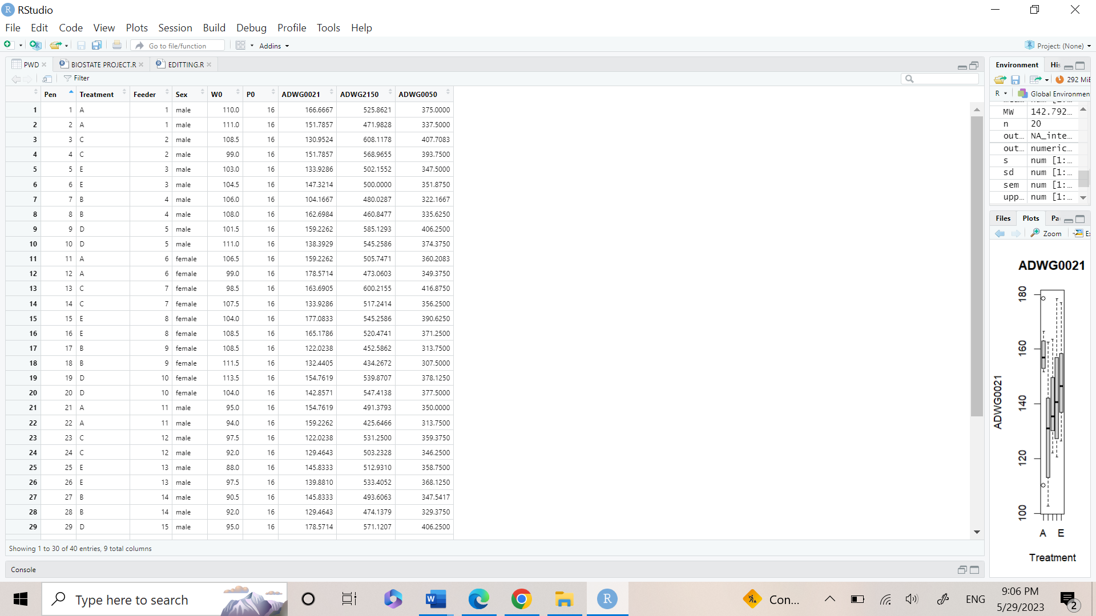
* Descriptive statistics (YOMNA)
* Graphics
* 1st: we made the frequency table for males and females. A frequency table shows the frequency or count of each unique value or category of a variable, along with its relative and/or cumulative frequencies.
* The code:

* The output:

The total sample=40

Males= 20

Females=20

* 2nd: We made a bar chart graph with mean ADWG0021in males and females.
* A bar chart is a graphical representation of categorical data in which the categories are displayed as bars of equal width and height proportional to the counts or percentages of each category. In a bar chart, the height of each bar represents the frequency or relative frequency of the category, and the bars are usually separated by small spaces to emphasize that the categories are distinct.
* Bar charts are useful for visualizing the distribution of categorical data and for comparing the frequencies or relative frequencies of different categories.
* The code:

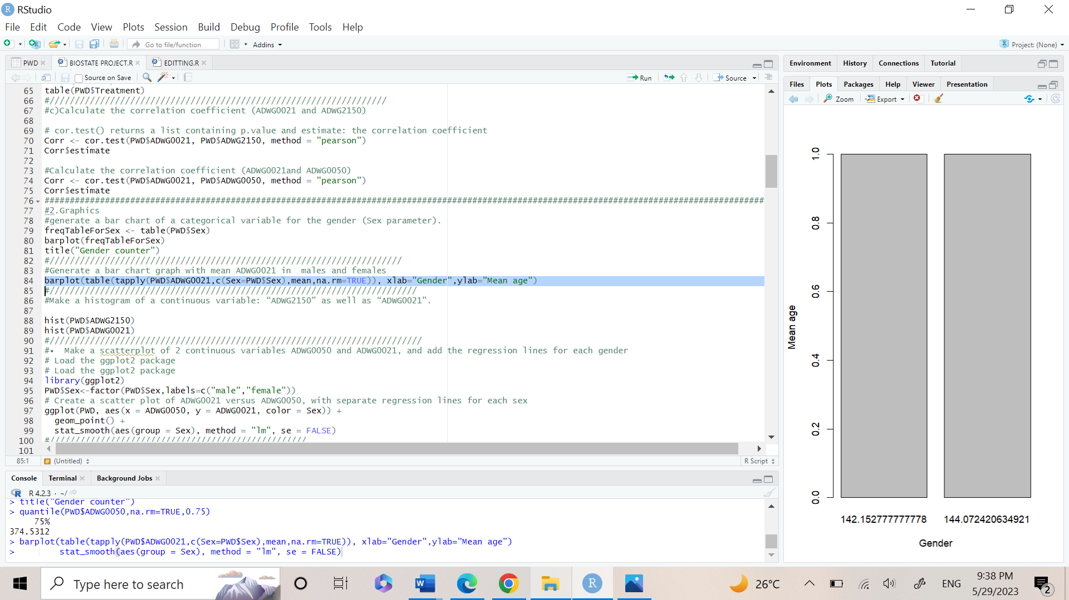

* 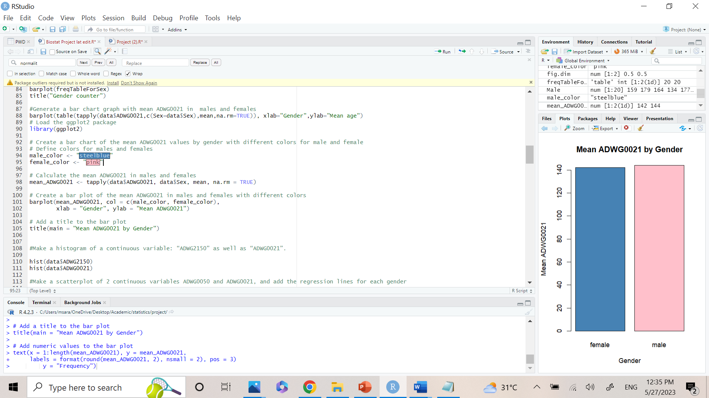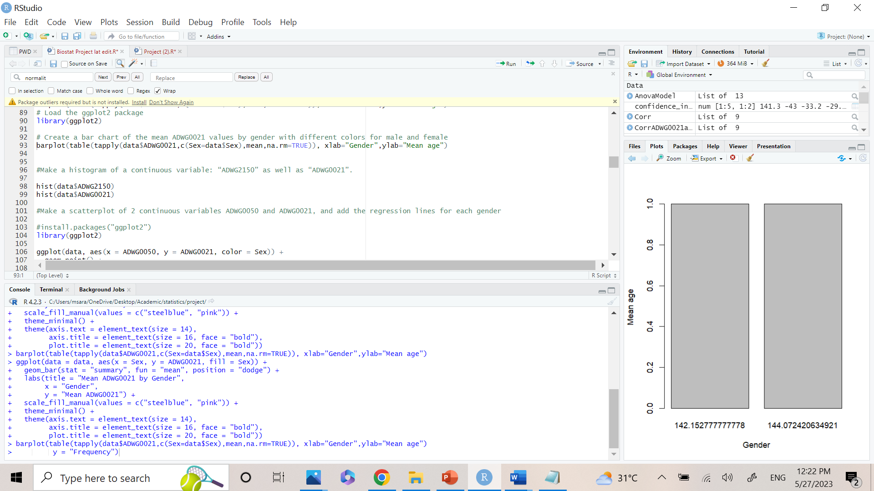The output:

result shows the mean value of ADWG0021 in males and females.

The mean of males is slightly greater than females.

Males’ mean = 144.07

Females’ mean = 142.15

* 3rd: Make a histogram of a continuous variable: “ADWG2150” as well as “ADWG0021”.
* Histograms are useful for visualizing the shape of the distribution of a continuous variable, as well as its center, spread, and skewness. A symmetric distribution, such as a normal distribution, will have a roughly bell-shaped histogram, with the highest frequency in the center of the distribution and lower frequencies towards the tails. It can be used to check normality, yet it is not so accurate. As a result, we can use the Shapiro test (as mentioned later).
* In the histograms : the x-axis is the number of data , while the y-axis is the frequency of data.
* 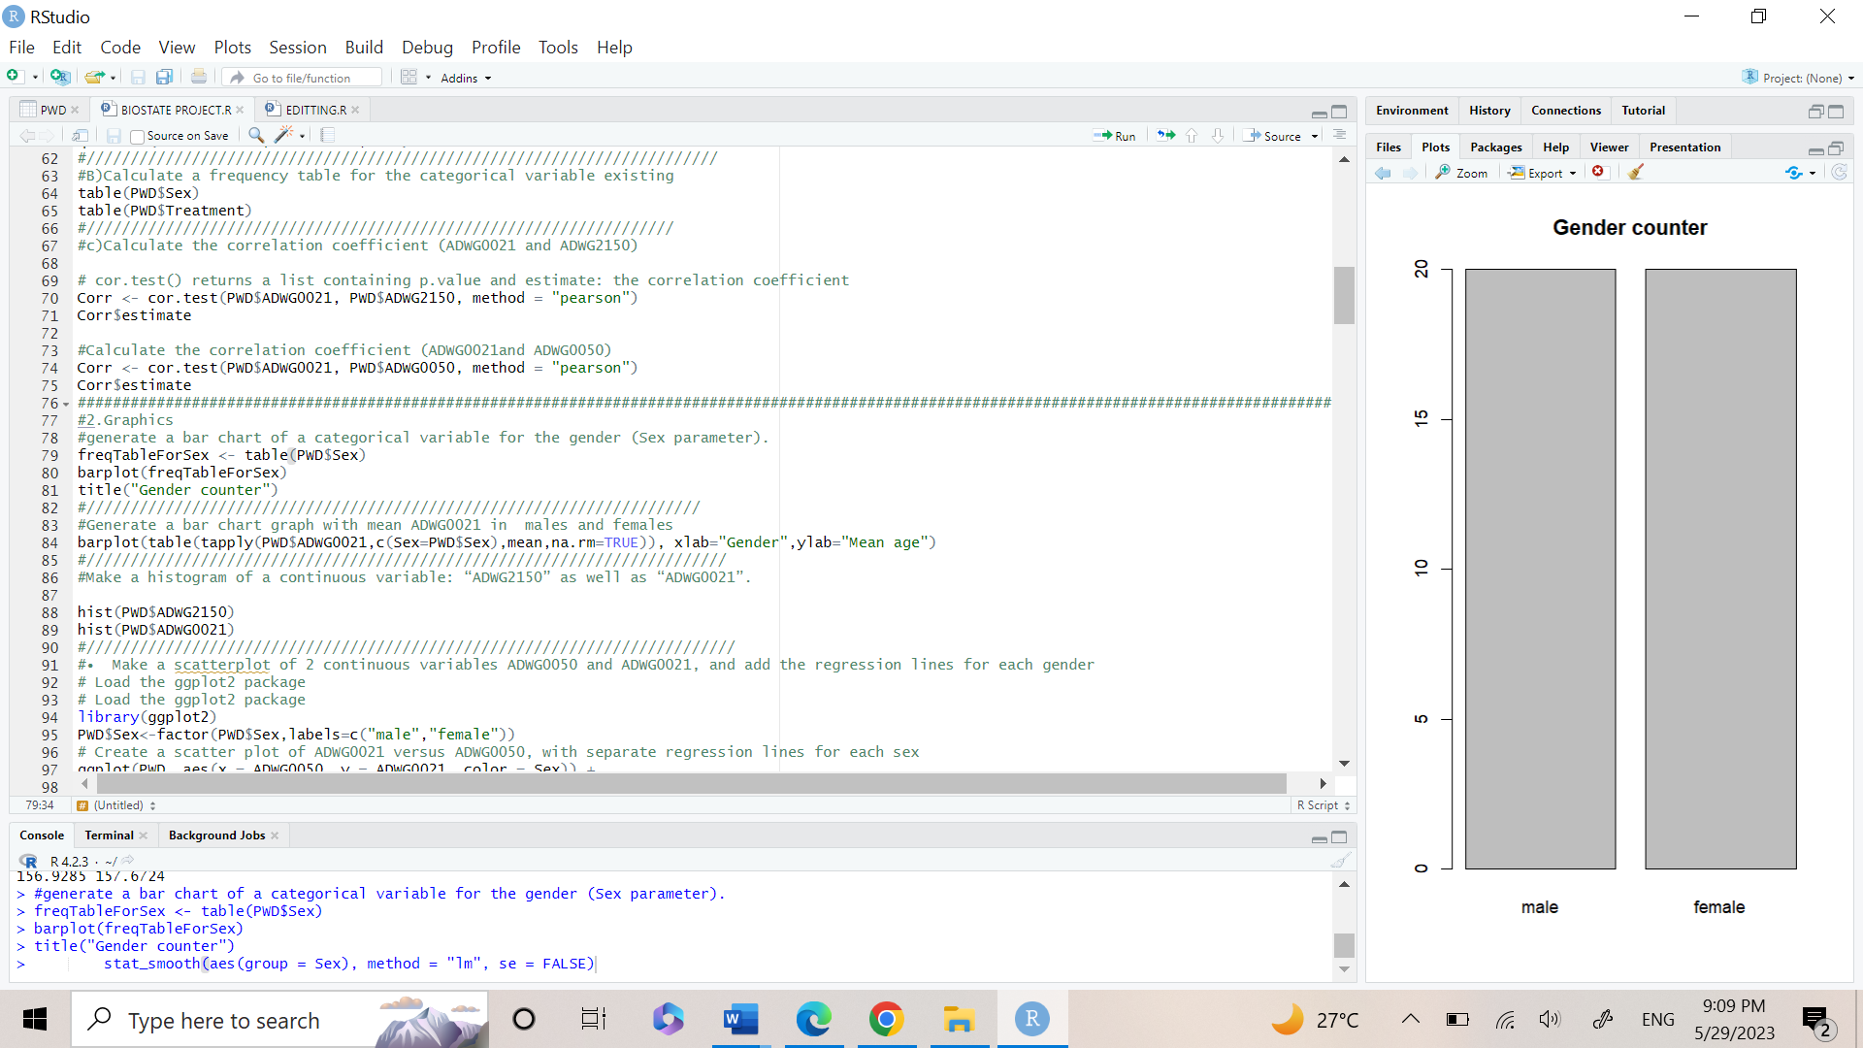The Code:

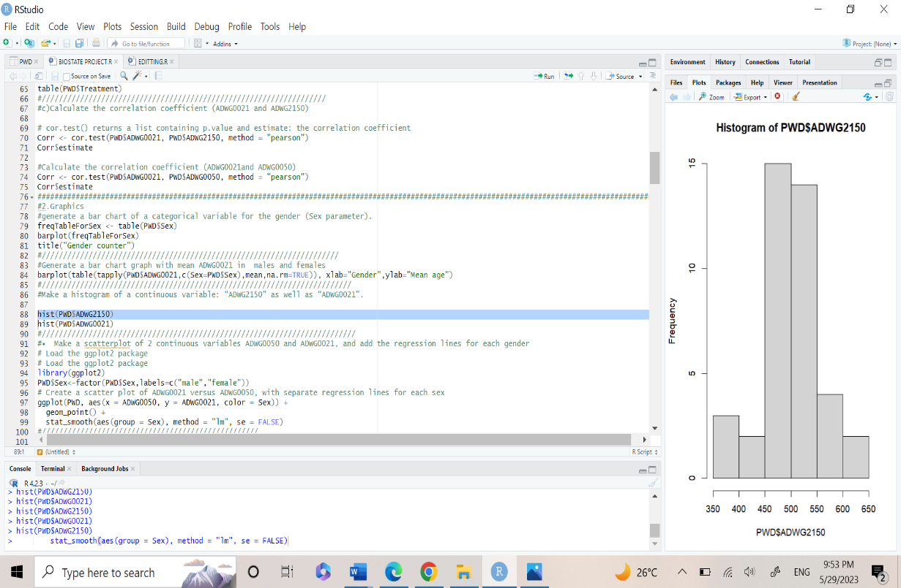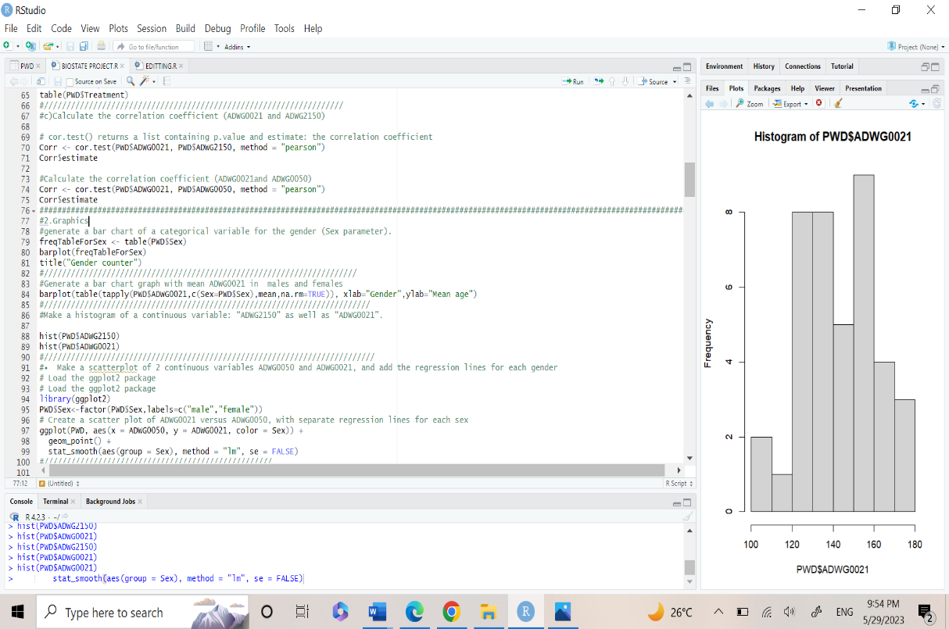

* The Output:

a) hist (PWD$ADWG2150):

The histogram shows normal data distribution in ADWG2150.

-This will be proven in detail later-

* b) hist (PWD$ADW0021):

The histogram shows normal data distribution in ADWG0021.

-This is not very clear so we will make Shapiro test later-

* 4th: We made a scatterplot of 2 continuous variables ADWG0050 and ADWG0021, and added the regression lines for each gender:
* A scatterplot is a graph that shows how two continuous variables relate to one another. A pair of data points are plotted together, with each point denoting the value of one variable on the x-axis and the other variable's value on the y-axis. The resulting figure displays the general shape of the relationship between the two variables, along with any potential trends, clusters, or outliers.
* Regression lines: used to visualize the relationship between two continuous variables in a scatterplot. It is a straight line that represents the best-fit relationship between two variables, based on a statistical model that describes the relationship between them.
* 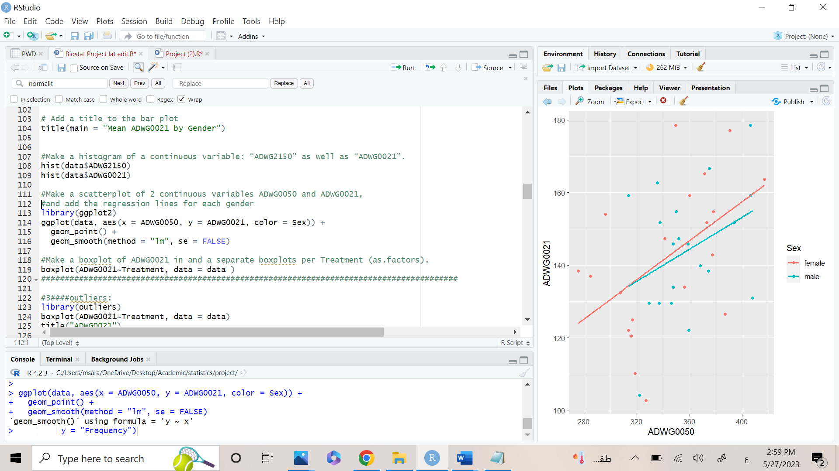The Code:

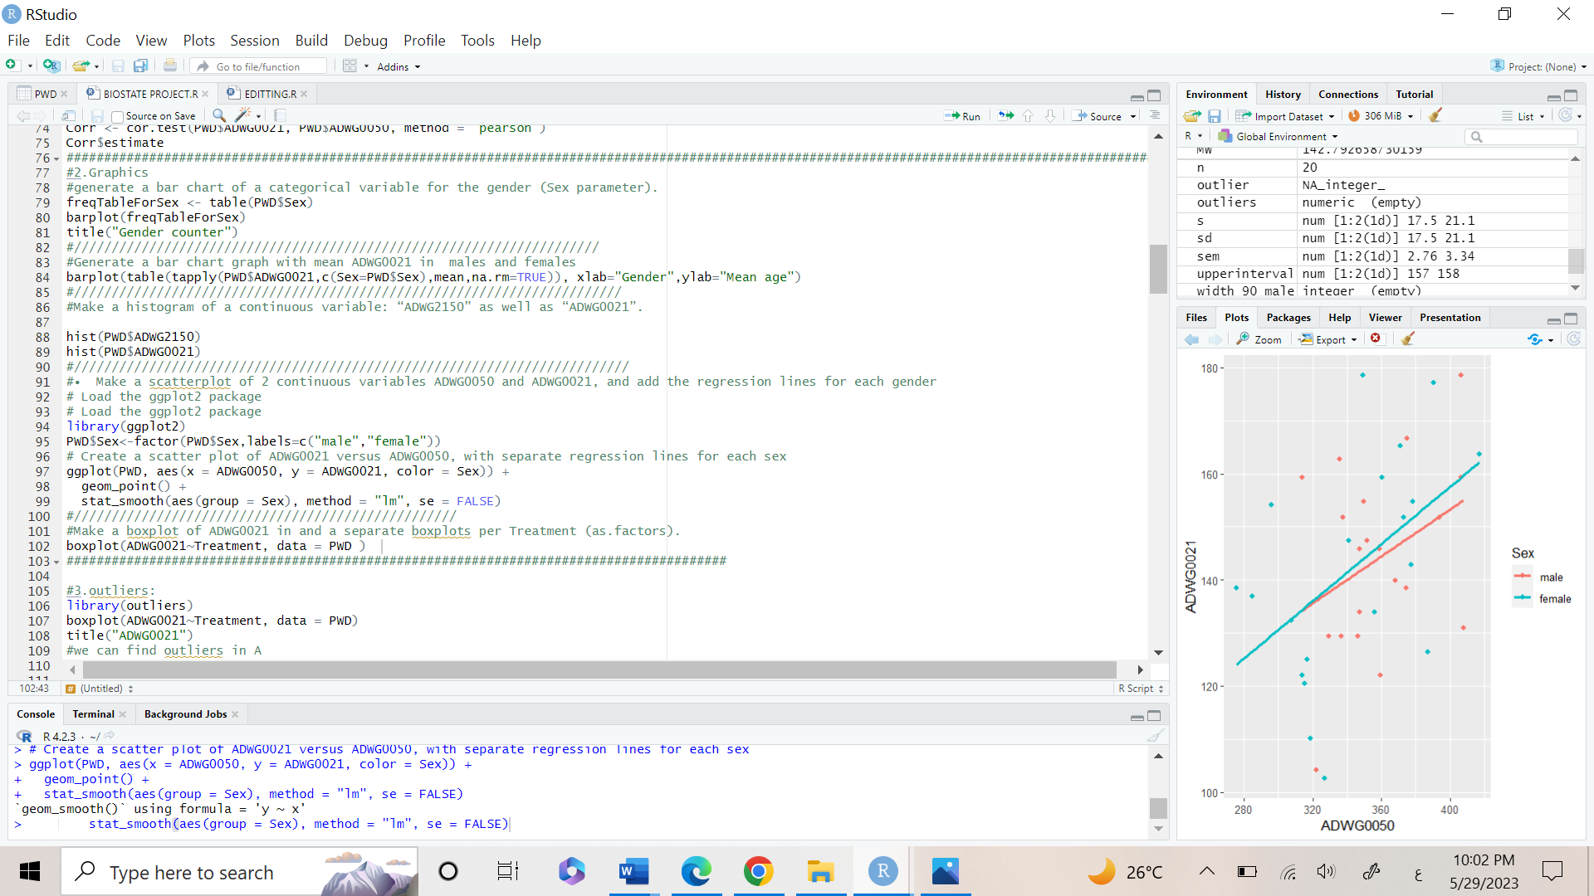

* The Output:

The scatter plot shows a very weak positive correlation (or no correlation) between the two variables.

* 5th: Make a boxplot of ADWG0021 and separate boxplots per Treatment (as. factors):
* A boxplot is a graphical representation of the distribution of a continuous variable or variables. Boxplots display a box that represents the middle 50% of the data, with a line inside the box representing the median value and "whiskers" that extend from the box to the minimum and maximum values, excluding outliers.
* Boxplots are particularly useful for comparing the distributions of multiple groups or variables, and for identifying potential outliers or extreme values in the data.
* The Code:
* The Output:
* In this output we are using separate boxplots to compare the effect of each treatment (A, B,C,D,E) on the variable ADWG0021 ,which represents the average daily weight gain between day 0 to day 21.

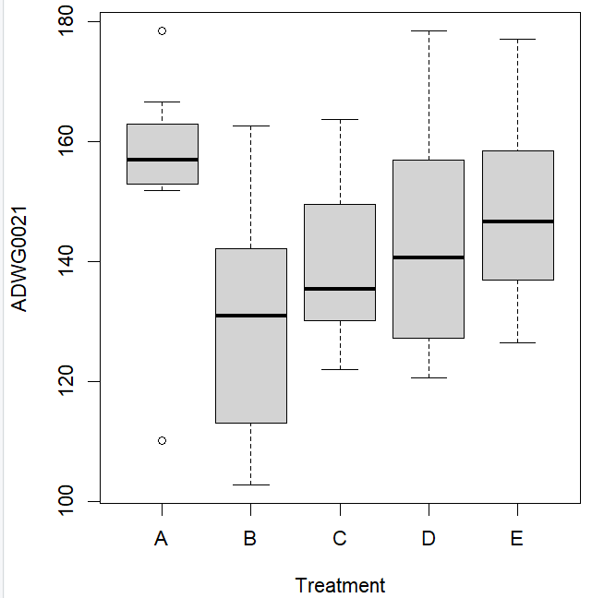

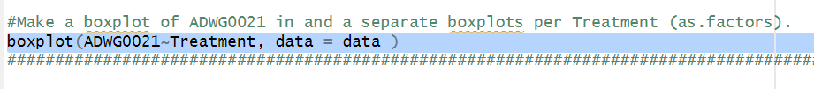

* Outliers
* Outliers are extreme or unusual values in a dataset that differ significantly from the majority of the other observations.
* It can occur due to various reasons, such as data entry errors, measurement errors, natural variation, or genuine anomalies in the data.
* It can have a significant impact on the analysis results, and it is important to identify and handle them appropriately.
* In this part of the project, we are exploring the data for any existing outliers. There are two methods to detect outliers. Firstly, using visual representations -boxplots-. Secondly, using Grubb’s test.
* The Code:

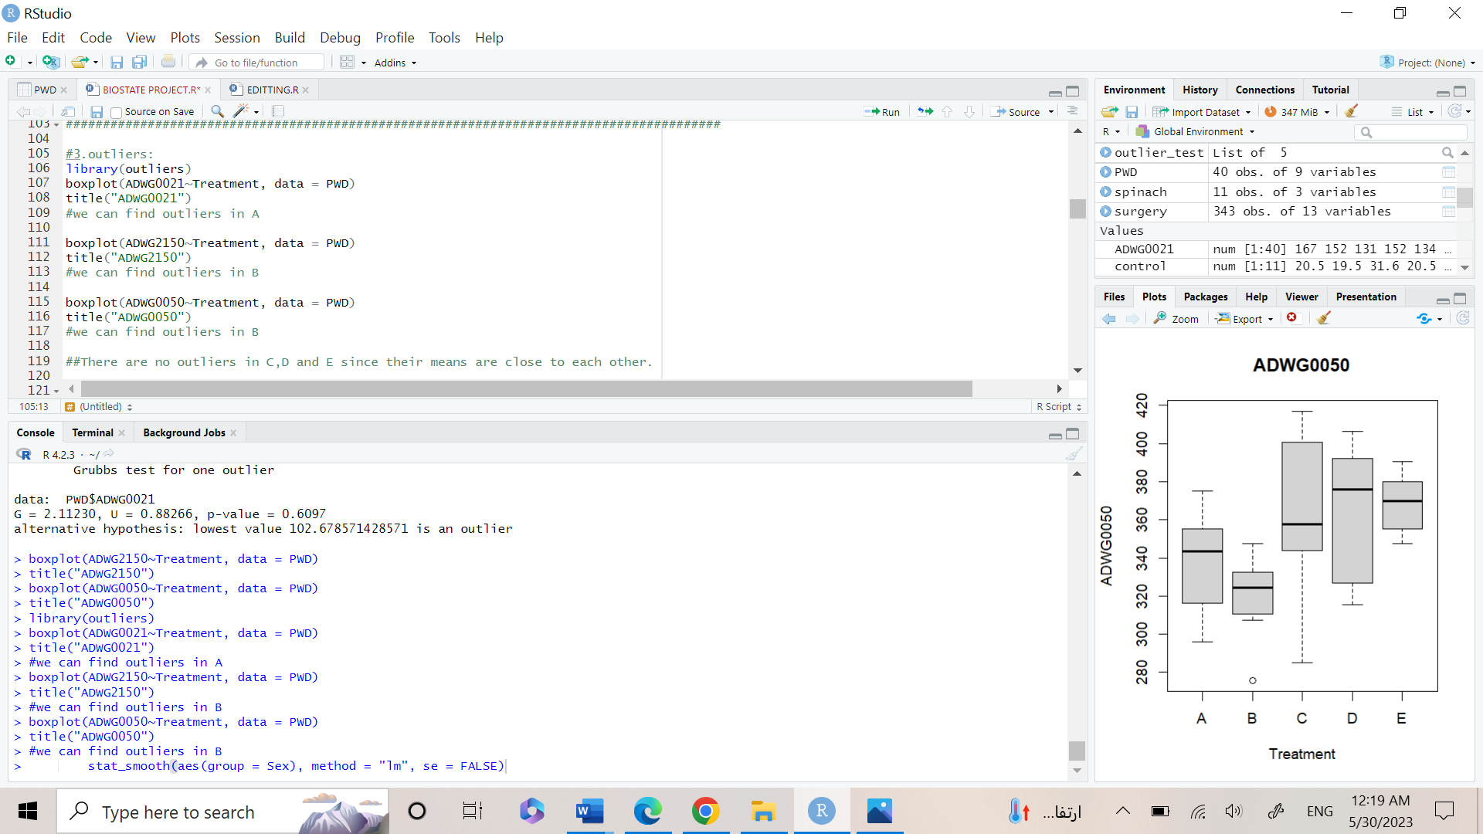

* The output of the visual representation.

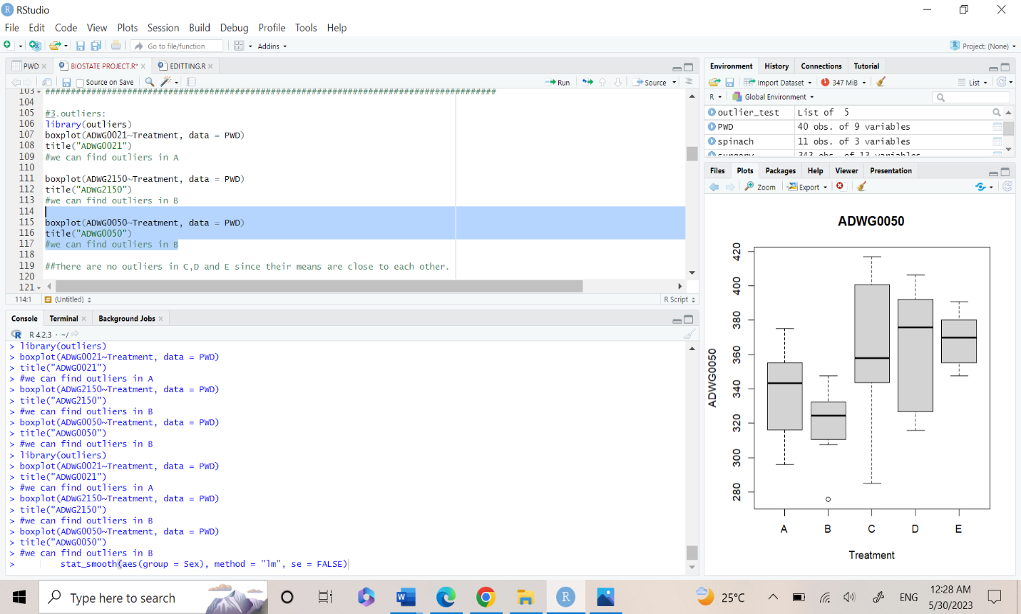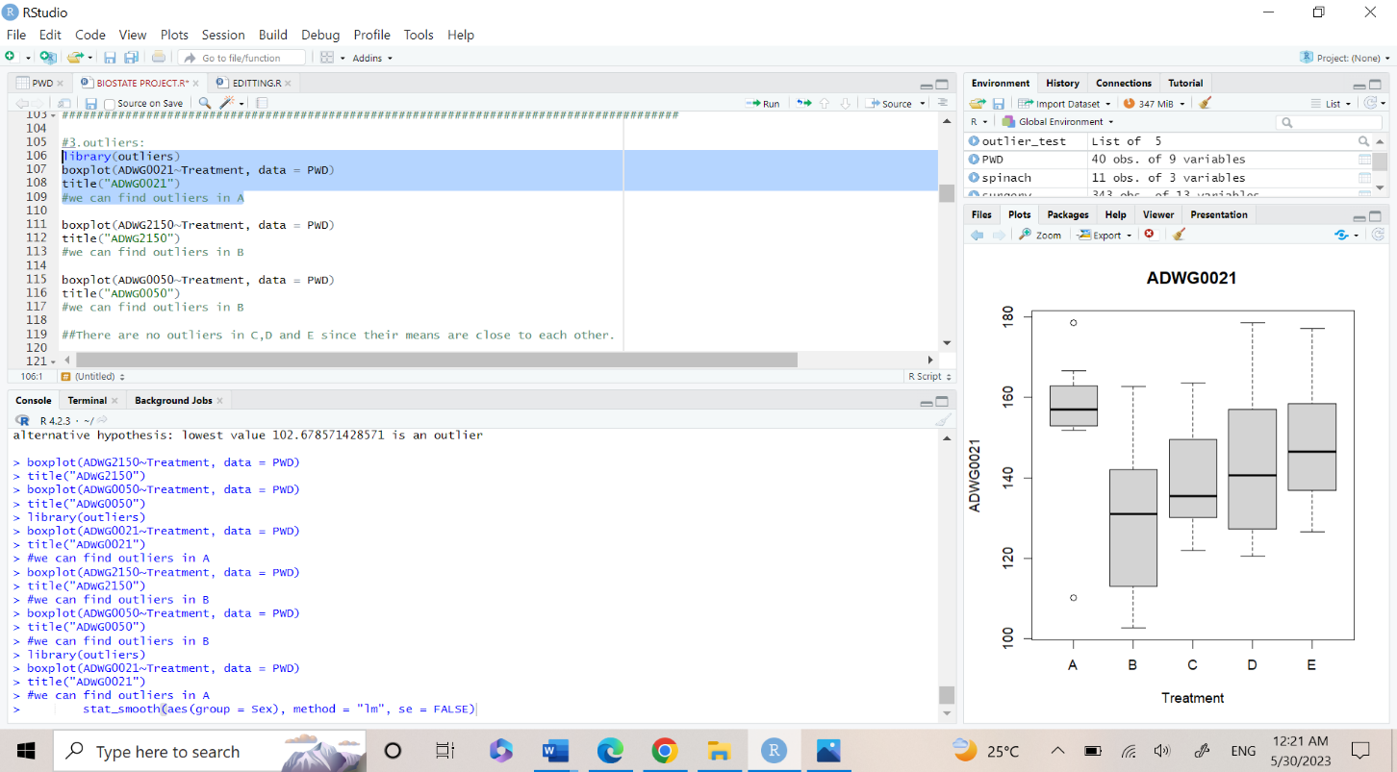

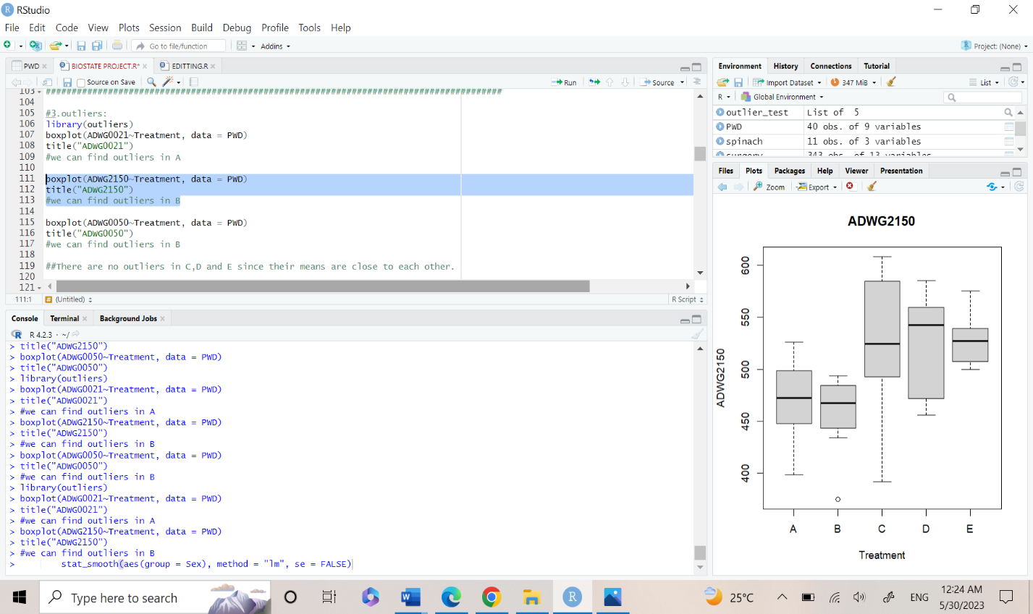

There is an outlier in Treatment B.

There is an outlier in Treatment B.

There is an outlier in Treatment A.

* Testing for normality/homoscedasticity

Checking normality using qq-plot and Shapiro-test:

* 1st: Using qq-plot:

A QQ-plot (quantile-quantile plot) is a graphical method used to test the normality of a dataset by comparing the observed distribution of the data to the expected distribution under a normal distribution.

If the points closely follow the line, then the data are likely to be normally distributed. If the points deviate from the line, it suggests that the data may be skewed, have heavy tails, or other departures from normality.

* The code

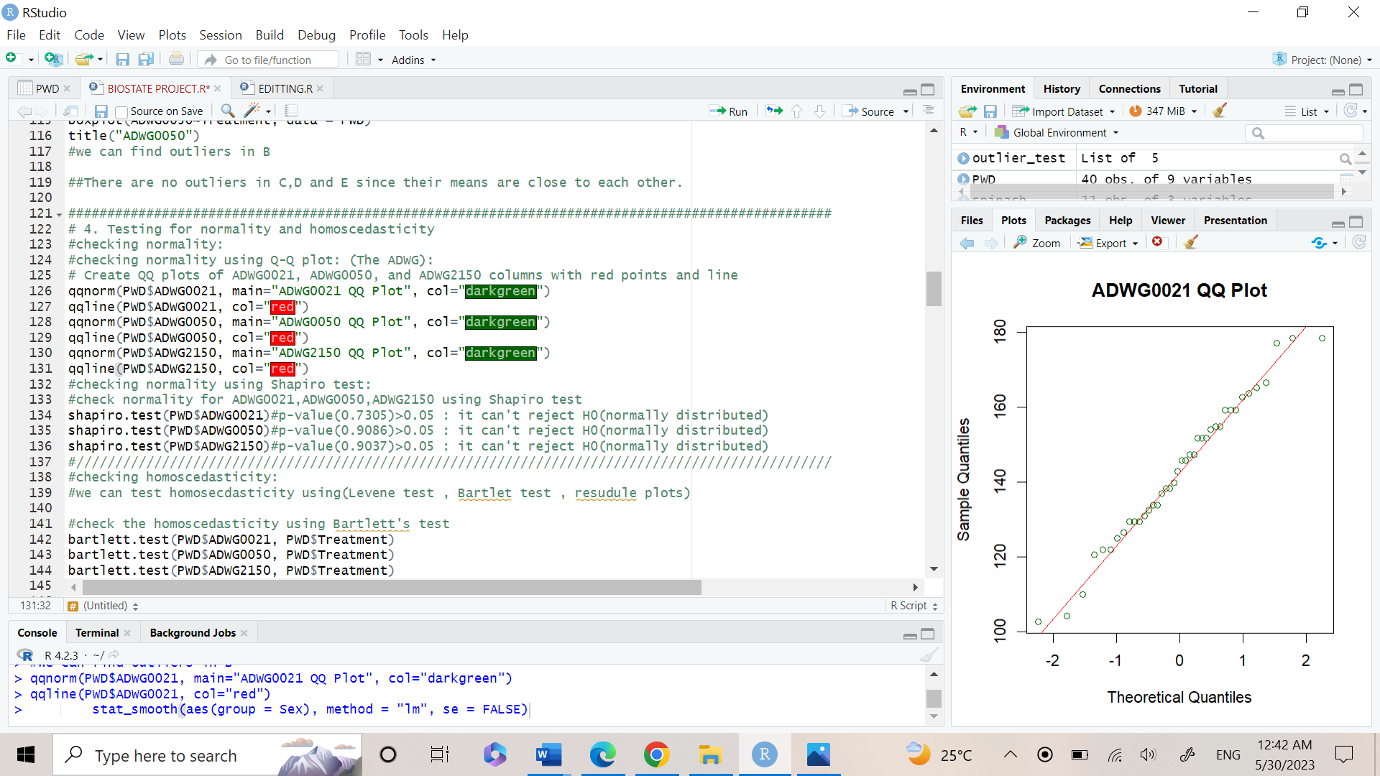

* The output:

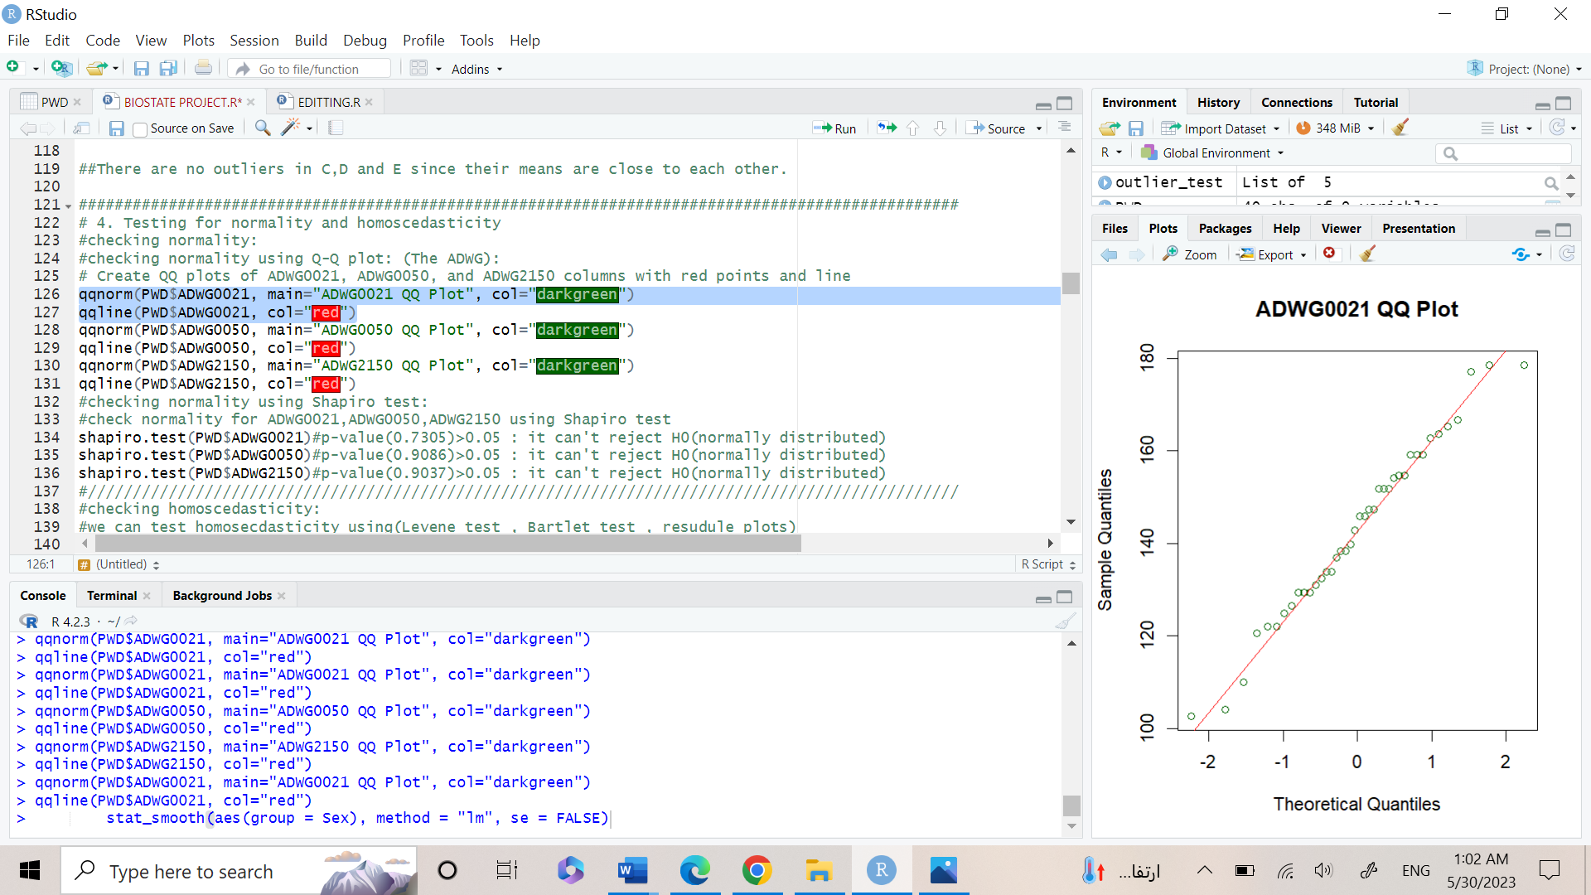

**The qq-plot of ADWG0021 shown reflects a normal distribution of data since the points follow a line.**

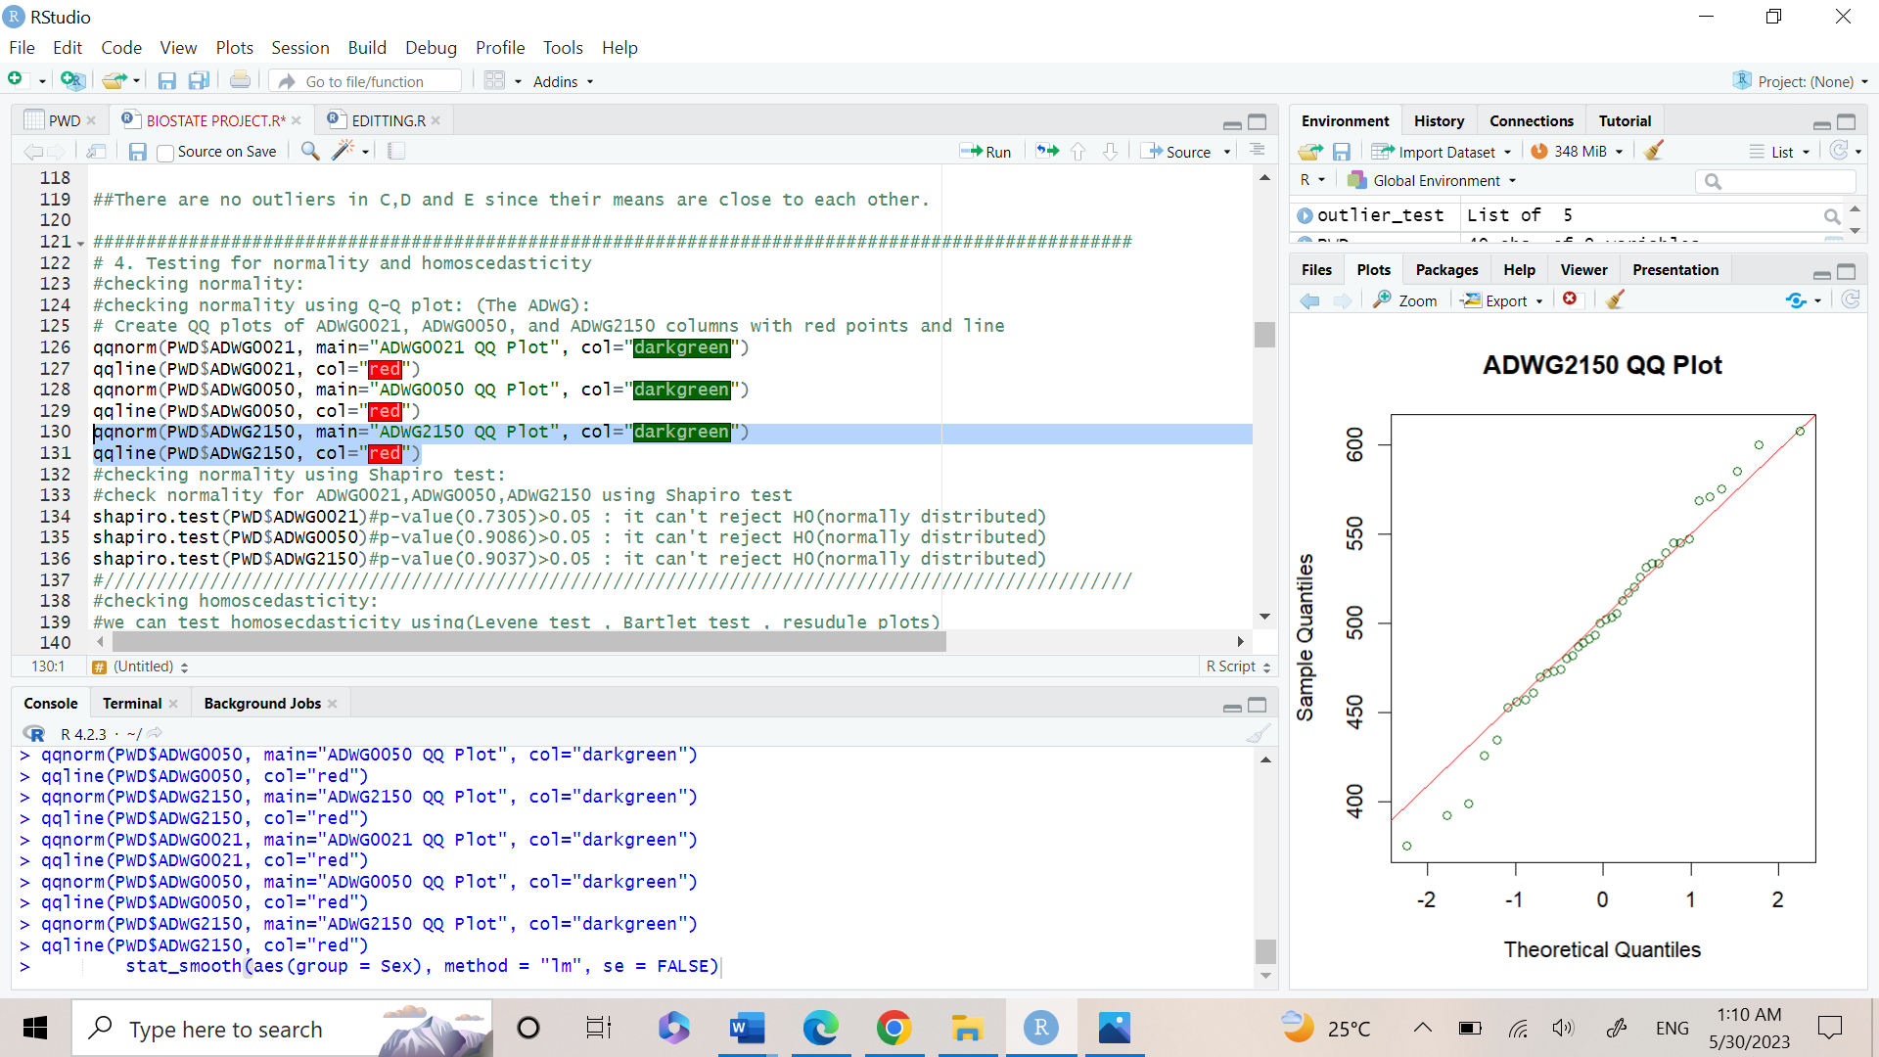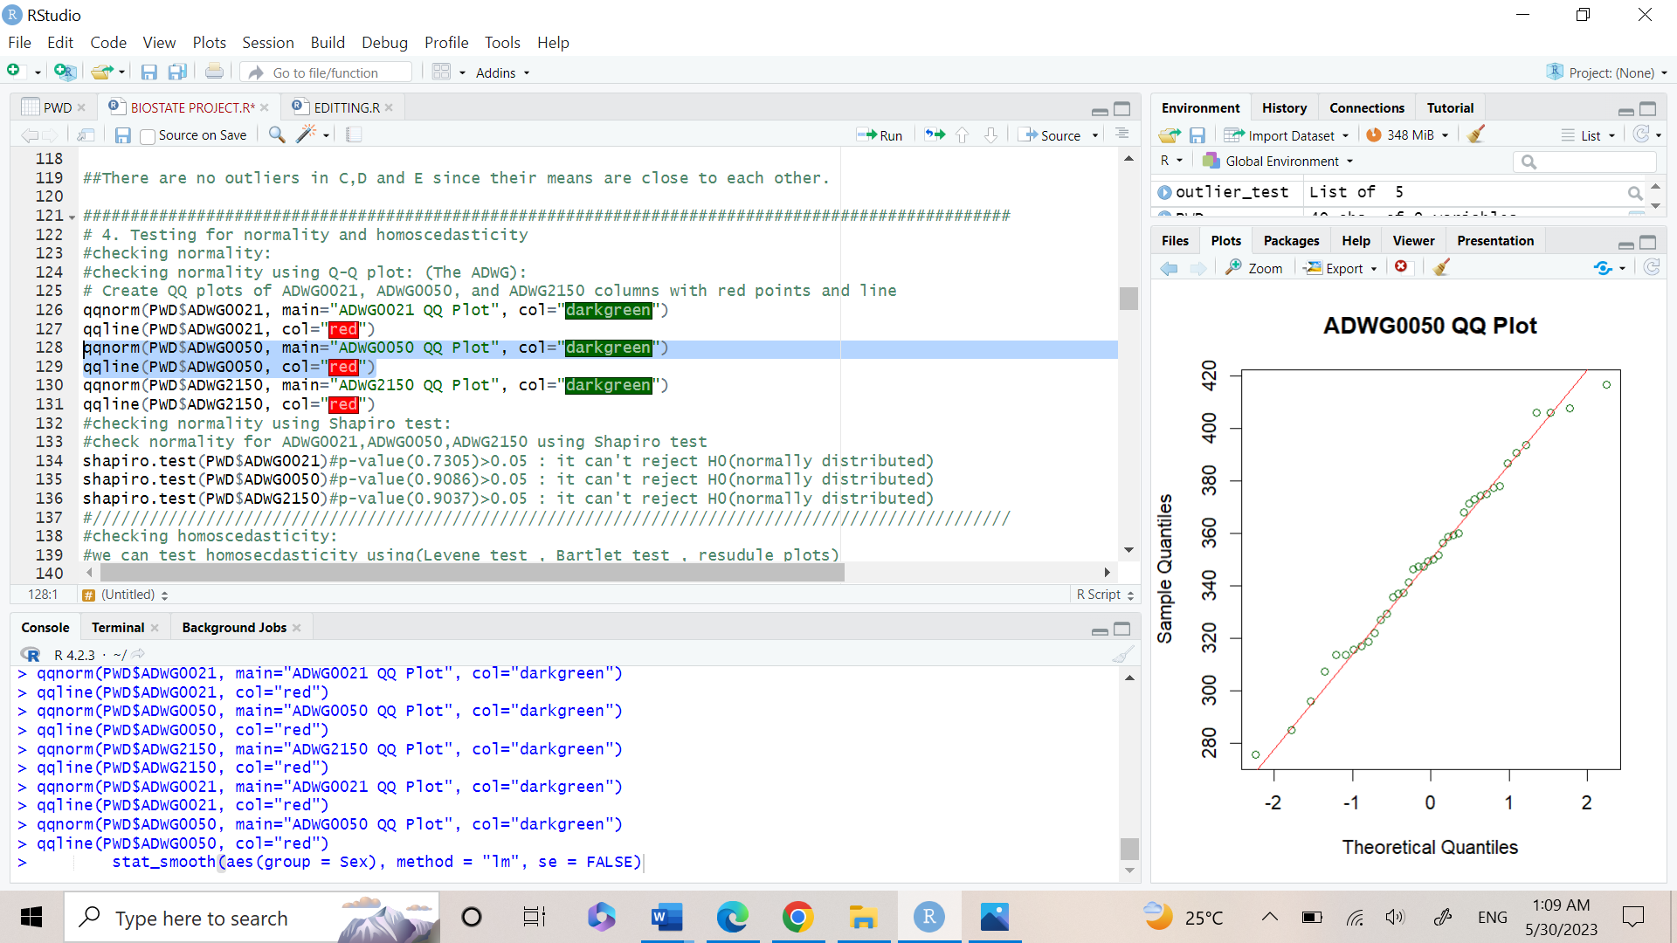k

**Both graphs reflect normal distribution because the plotting between the observed versus the expected follow a line.**

* 2nd: Using Shapiro-test:

The Shapiro-Wilk test is a statistical test used to assess the normality assumption of a dataset.

The null hypothesis of the Shapiro-Wilk test is that the data are normally distributed, and the alternative hypothesis is that the data are not normally distributed.

* 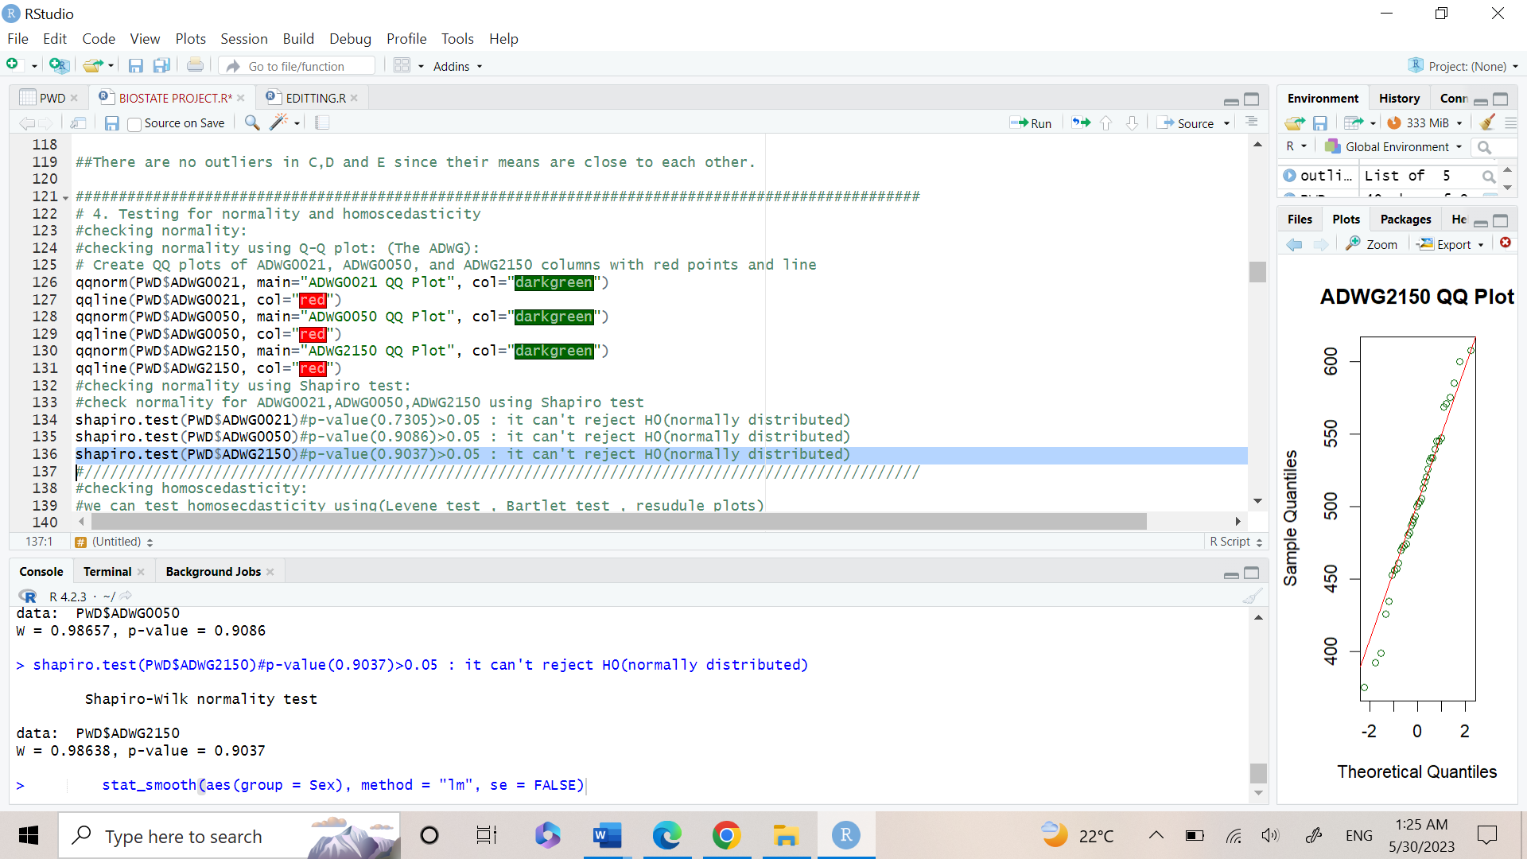The code
* 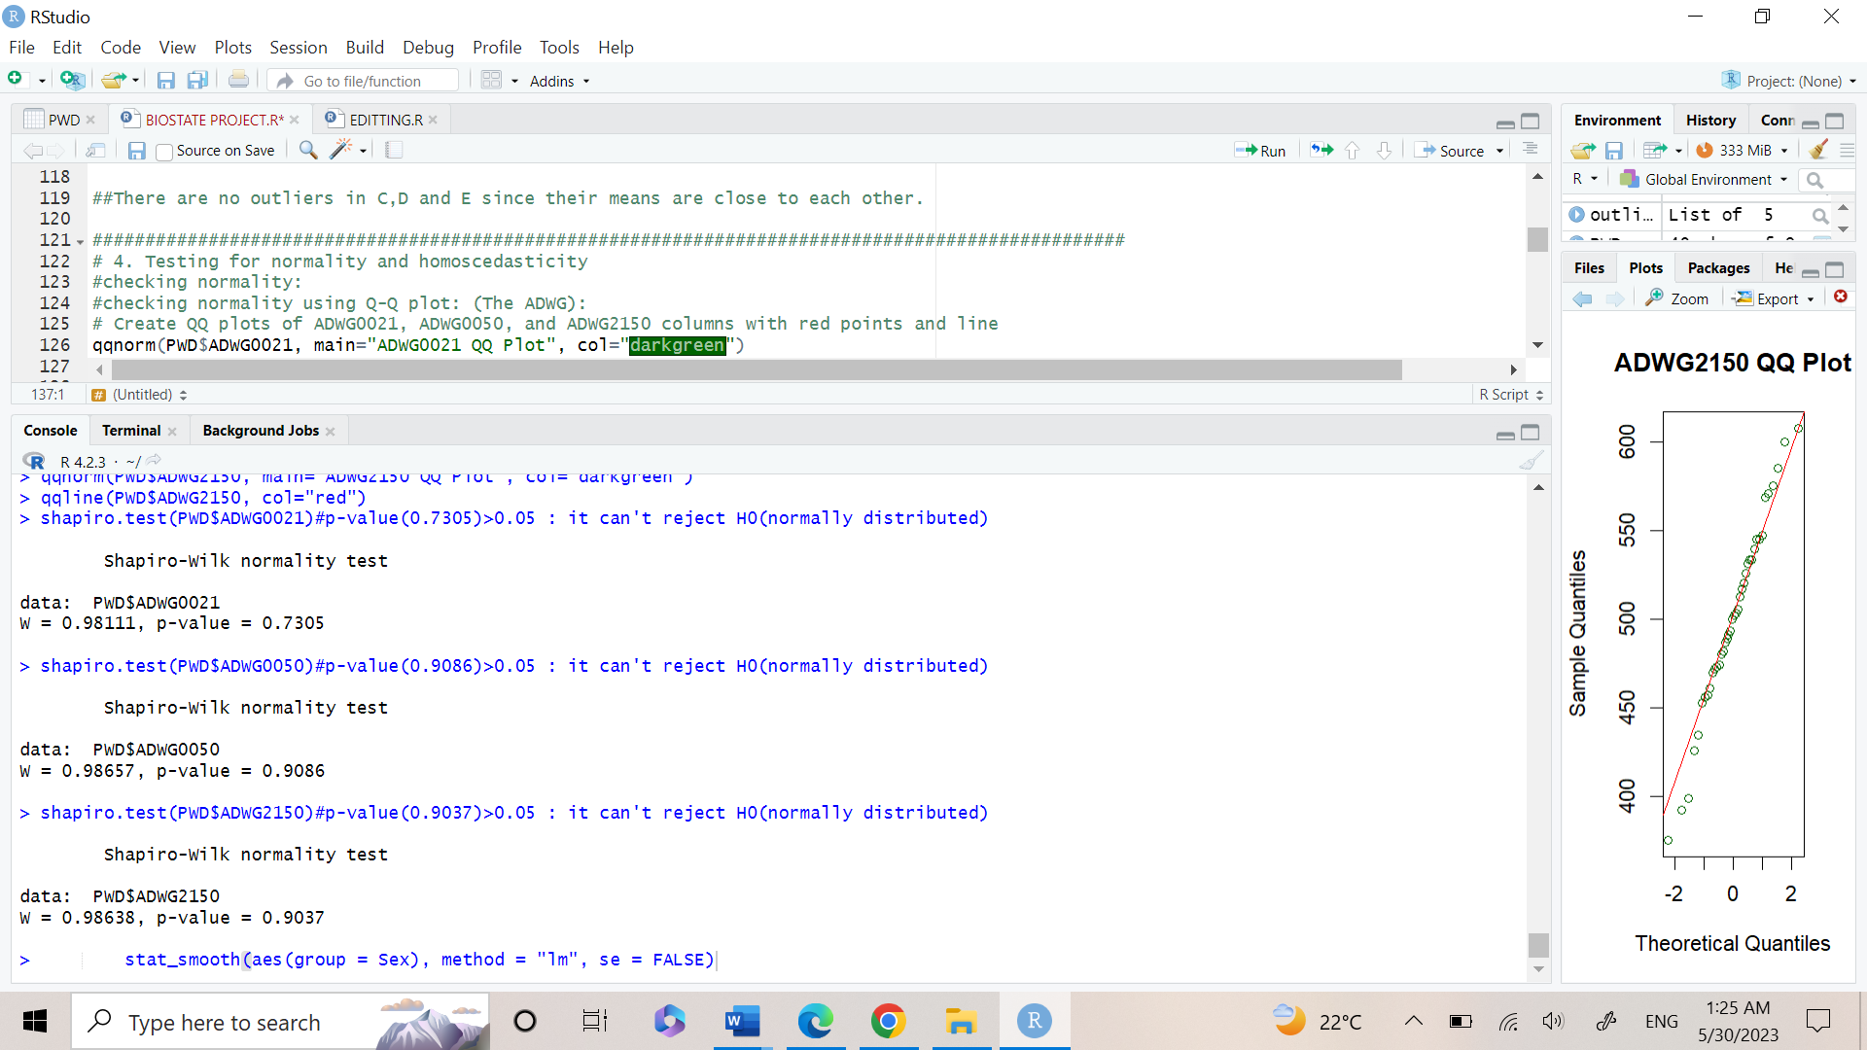The output
* Result of Shapiro test in ADWG0021, ADWG0050, ADWG2150:

p-value>0.05: not enough evidence to reject null hypothesis.

Checking homoscedasticity using Bartlet’s test and Levene’s test:

* 1st: Using Bartlet’s test:

The Bartlett test is a statistical test used to assess the homogeneity of variances across multiple groups or samples.

The null hypothesis of the Bartlett test is that the variances across all groups are equal, and the alternative hypothesis is that at least one group has a different variance than the others.

The Bartlett test assumes that the data are normally distributed and that the sample sizes are approximately equal across all groups.

* 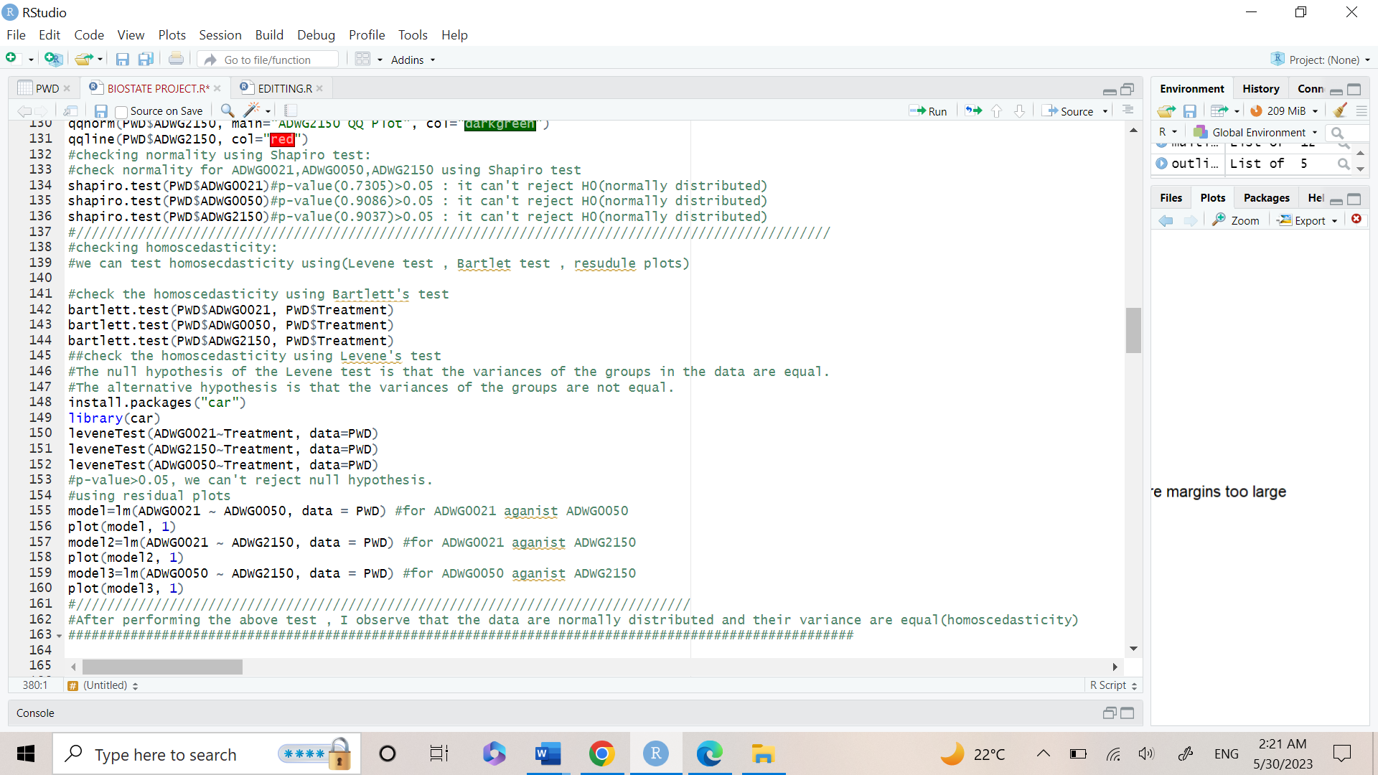The Code
* The Output

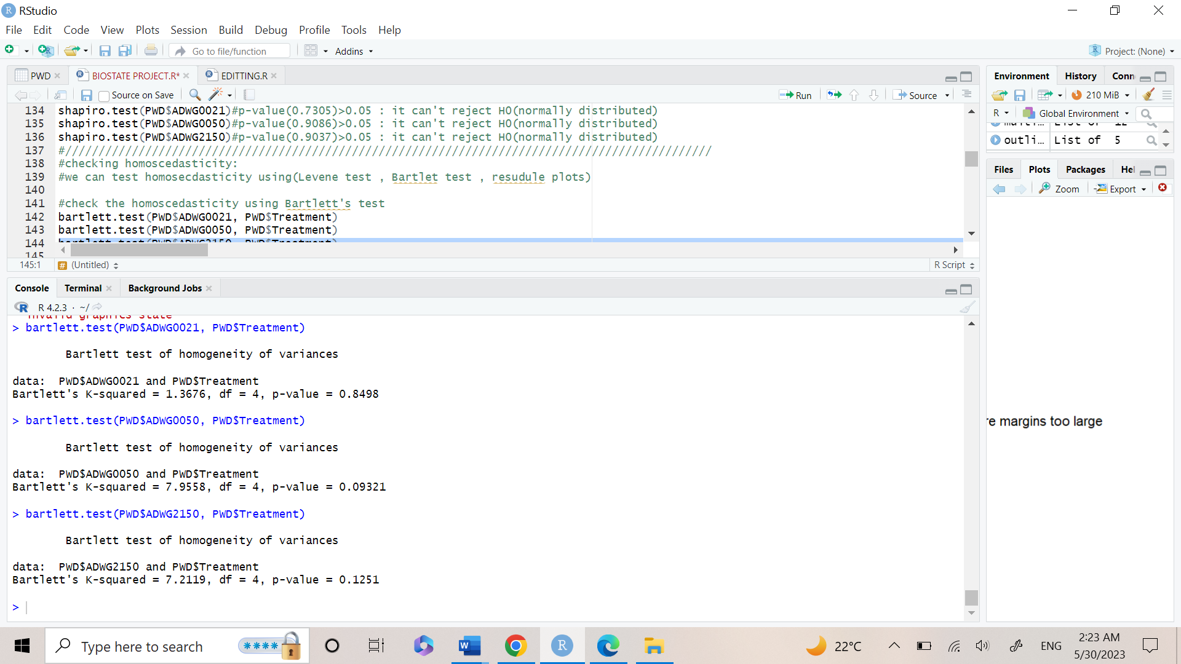

* Result of Bartlet test in ADWG0021, ADWG0050, ADWG2150:

p-value>0.05: not enough evidence to reject null hypothesis.

* Therefore, the null hypothesis of homoscedasticity can’t be rejected.
* 2nd: Using Levene’s test:

The Levene test is a statistical test used to assess the homogeneity of variances across multiple groups.

The null hypothesis of the Levene test is that the variances across all groups are equal, and the alternative hypothesis is that at least one group has a different variance than the others.ps or samples.

The Levene test can test data that is normally or not normally distributed, unlike Bartlet’s test.

* The code:

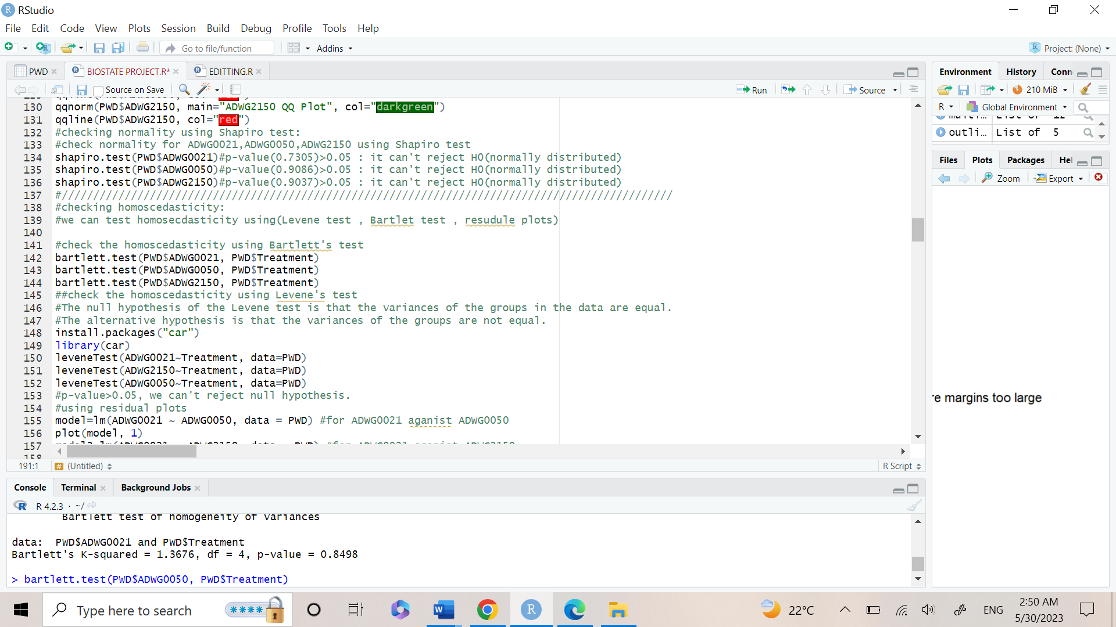

* The output:

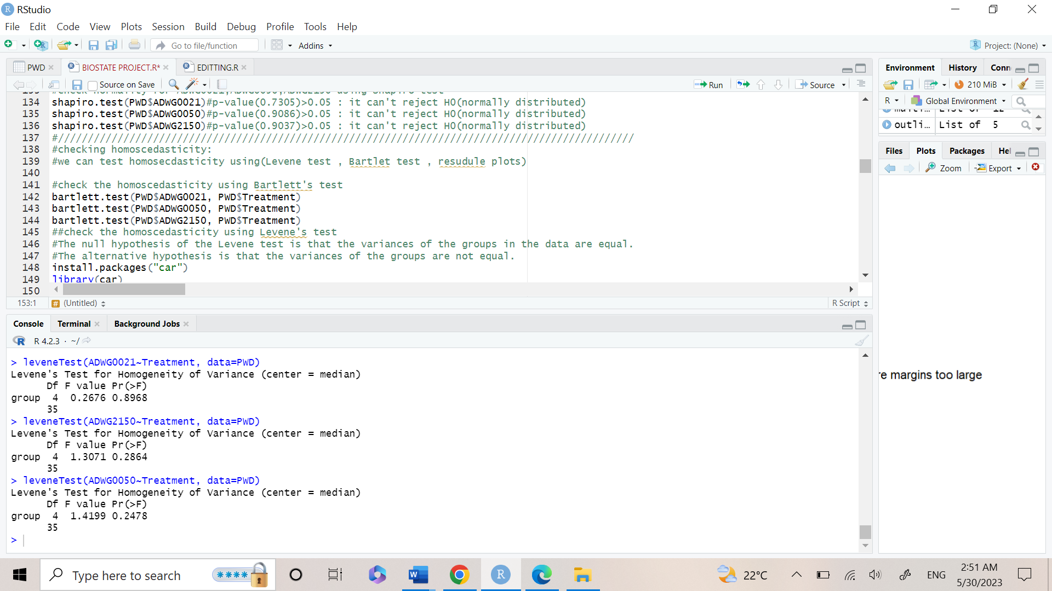

* Result of Levene test in ADWG0021, ADWG0050, ADWG2150:

p-value>0.05: not enough evidence to reject null hypothesis.

* Therefore, the null hypothesis of homoscedasticity can’t be rejected.
* After making the Bartlet test and Levene test, both agreed that the data is:

1. Normally distributed
2. Homoscedasticity

* Statistical Inference
* It is the process of drawing conclusions about a population based on a sample of data from that population.
* We will calculate the 90%, 95%, 99% confidence interval for the means of ADWG0021per each gender.
* A confidence interval (CI) is a range of values that is likely to contain the true value of a population parameter, such as the mean or proportion, with a certain level of confidence.
* The Code:

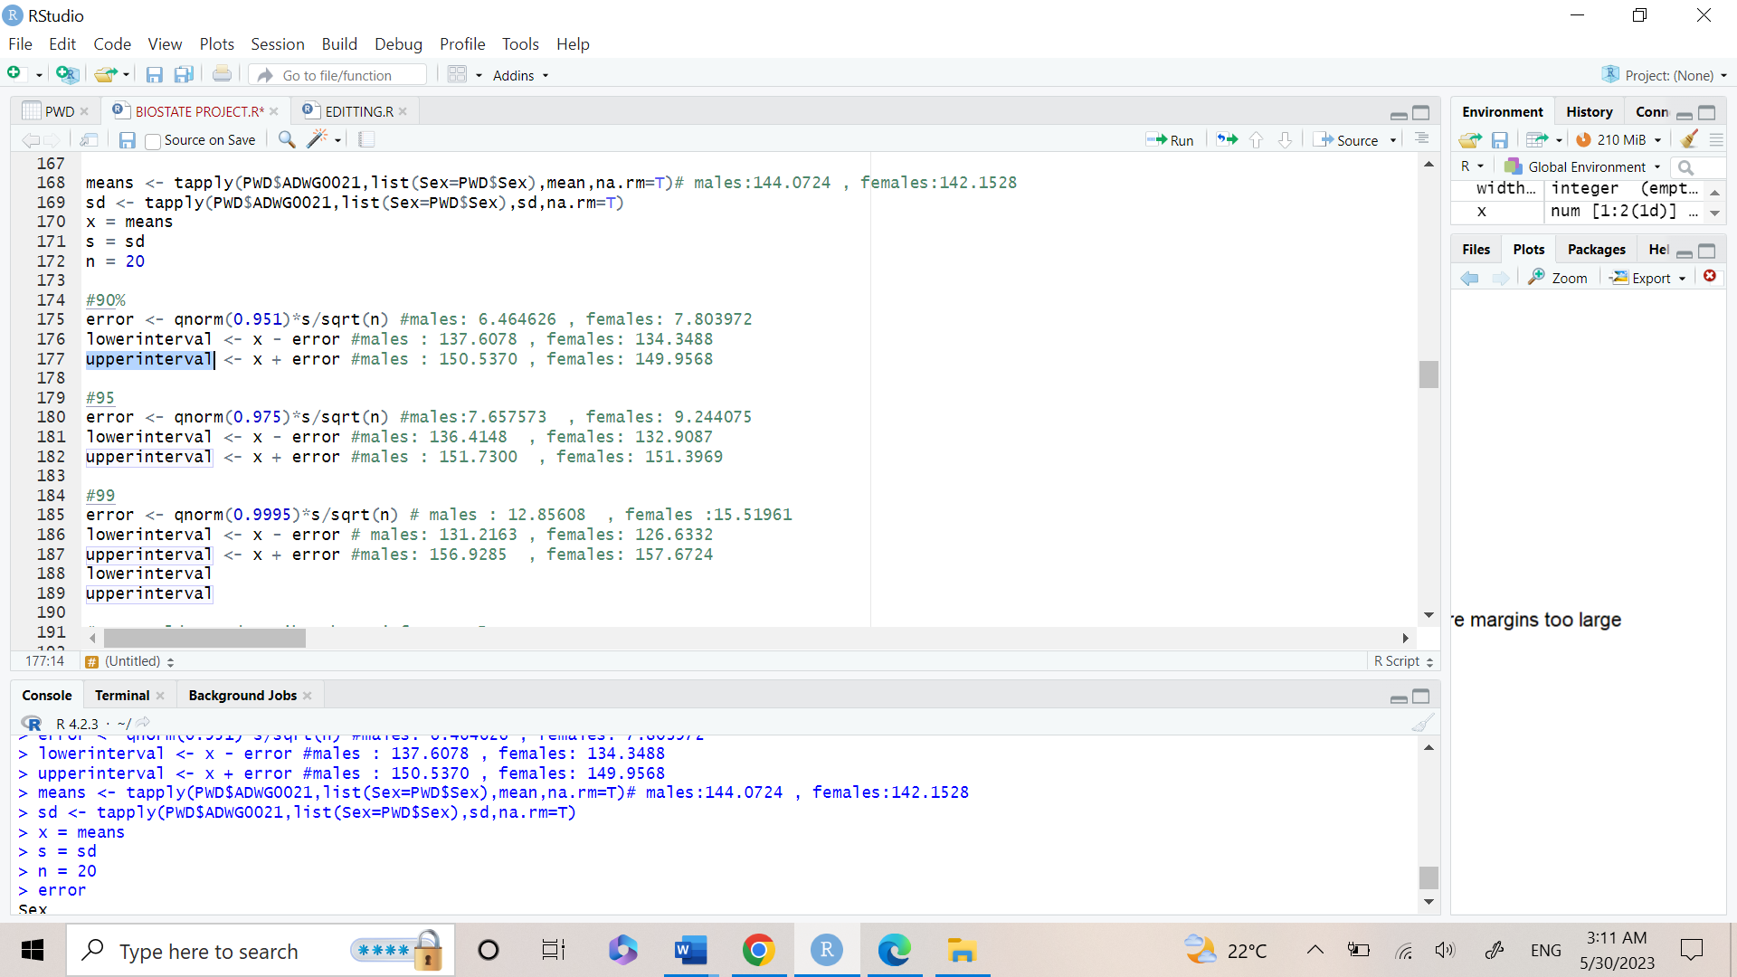

* The Output:

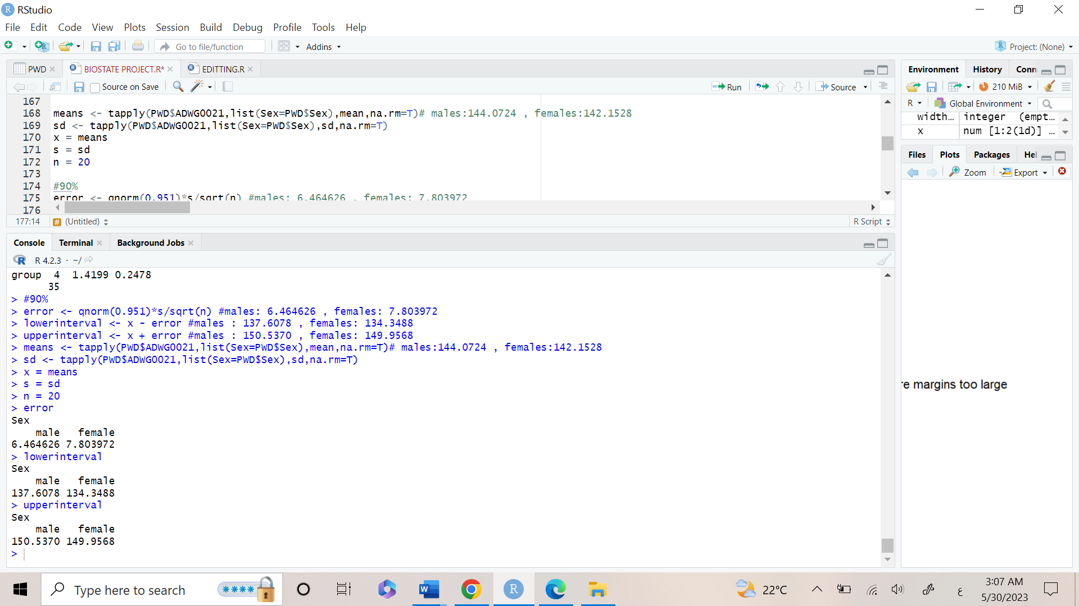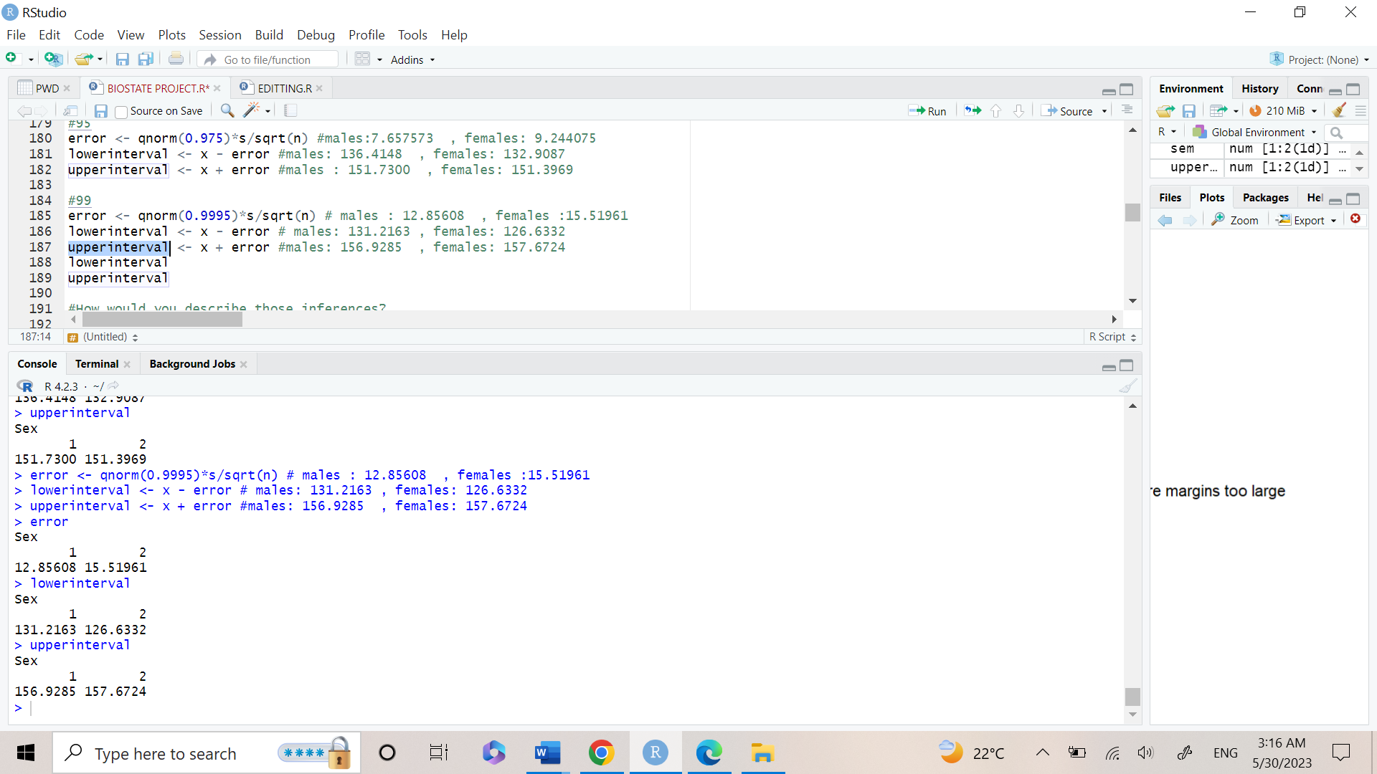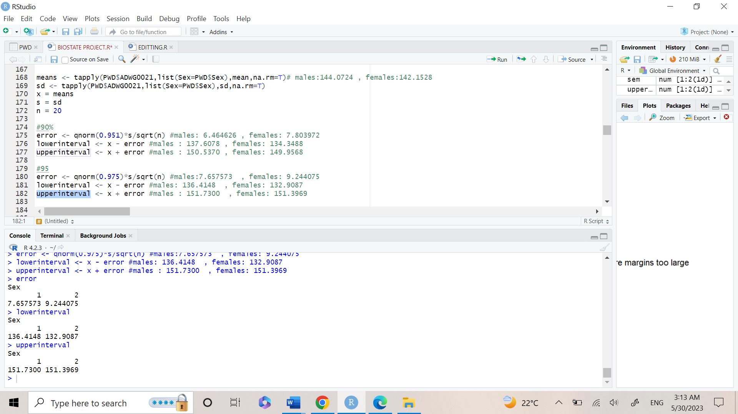

**Analysis of each Confidence intervals (90%, 95%, 99%) respectively**

The first line (in blue) shows the values of the error.

The second line (in blue) shows the lower interval, while the third line shows the upper interval.

How would you describe those inferences?

* confidence interval for the means of the average daily weight gain (g/day)
* in the period between 0 and 21 days post-weaning per each gender shows that
* with 90% confidence interval in males: values are between : 139.5012 - 148.6436
* with 95% confidence interval in males: values are between :138.6577 - 149.4871

What do you observe in terms of the interval width when request higher confidence?

* We noticed that by increasing the confidence interval the range is wider(width increases) ,
* therefore, the error range increase but with more certainty to have the true value included in the interval
* Hypothesis Testing
* **A)1)We hypothesis that ADWG0021 is different between male vs female.**
* First, we create two new variables Male and Female which contain the values of ADWG0021 for males and females(Male= 2 and female= 1).
* The code is used to do a two-sample t-test to compare the means of two groups in the data frame PWD based on a continuous variable ADWG0021 and a categorical variable Sex. And the output, including the t-statistic, degrees of freedom, p-value, and confidence interval.
* t.test performs a Welch two-sample t-test to compare the means of ADWG0021 between males and females.
* The sample estimates: report the means of ADWG0021 for males and females, which are 144.0724 and 142.1528, This explains that males have slightly higher values of ADWG0021 than females, but the difference is not statistically significant.
* The Code:

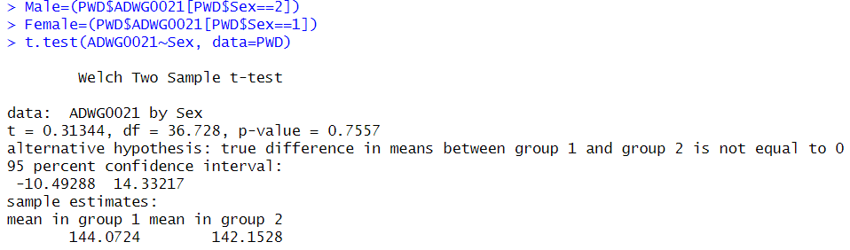

* The Output:
* Our Null hypothesis is that male and female are not different
* Alternative hypothesis : Male and female are different
* P-VALUE= 0.7 > 0.05 { Since p-value is greater than alpha value(0.05) which means that we don’t have enough evidence to reject null hypothesis and supporting alternative hypothesis }.



* **2)1st : Assuming normality and homoscedasticity, can you test this hypothesis using statistical hypothesis framework, assess whether the previous test assumptions have been met for the test.**
* Assess whether the previous test assumptions have been met for the test: By testing normality using ( Histogram, Q-Q-plot, Shapiro-test)
* Histogram: The code is used to create two histograms of a continuous variable, separated by a categorical variable, to visually assess any differences in the distribution of the variable between the two groups.
* The Code

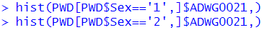

* The Output:

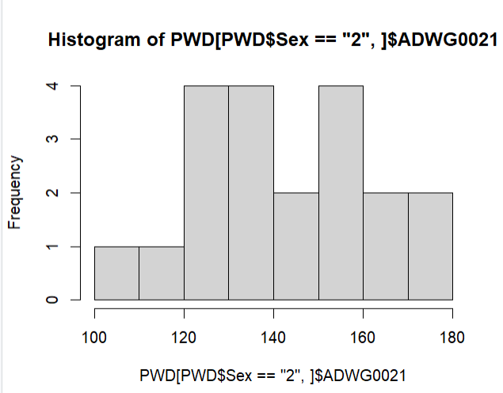

* Histogram doesn’t describe whether the data is normally distributed or not, so we used Shapiro-test to check the normality of the data.
* 1.Q-Q-plot and Shapiro-test for males:
* The Code

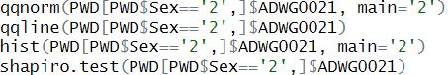

* The Output:

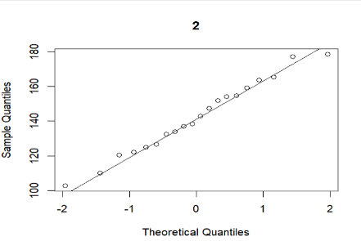

* In Q-Q-plot : Since points on the plot fall close to the line, it indicates that the data is normally distributed.

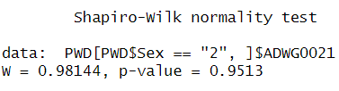

* Our The null hypothesis : data is normally distributed
* The alternative hypothesis : data is not normally distributed
* Shapiro-test output : P-value= 0.9513 Since p-value is greater than alpha value(0.05) which means that we don’t have enough evidence to reject null hypothesis and supporting alternative hypothesis }.
* 2.Histogram, Q-Q-plot, and Shapiro-test for Females:
* The Code:

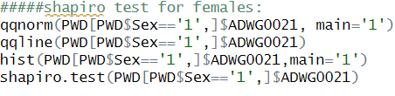

* The Output:

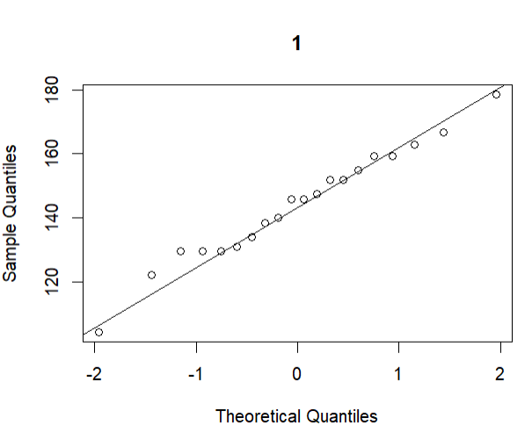

* The straight line fit most of the points, so this shows that the data is normally distributed.

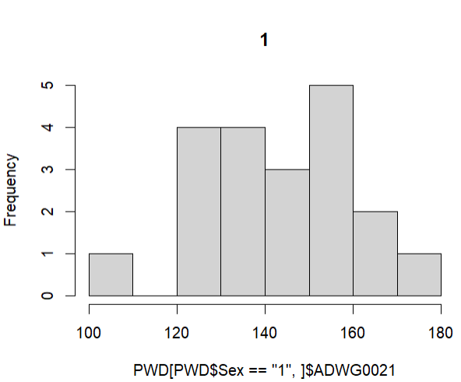

* Histogram doesn’t describe whether the data is normally distributed or not so we used Shapiro-test to check the normality of the data.

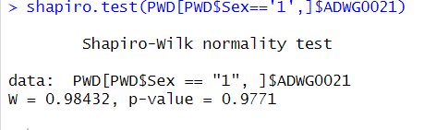

* Our The null hypothesis : data is normally distributed
* The alternative hypothesis : data is not normally distributed
* Shapiro-test output : P-value= 0.98432 Since p-value is greater than alpha value(0.05) which means that we don’t have enough evidence to reject null hypothesis and supporting alternative hypothesis }.
* In conclusion: (For proving normality of our data)
* The null hypothesis : data is normally distributed
* The alternative hypothesis : data is not normally distributed
* Since p-values of both males and females > alpha(0.05) , then we don't have enough evidence to reject the null hypothesis and support the alternative hypothesis.
* We assume normality(no enough evidence to support non normality) ,so previous test assumptions have been meet for the normality test, Therefore we proved normality using qq-plot and Shapiro-test.
* By comparing the two histograms, we can visually assess any differences in the distribution of ADWG0021 between males and females. For example, if one histogram has a higher peak or is more spread out than the other, it may indicate a difference in the mean or variance of ADWG0021 between the two groups, but the two histograms show that both distributions of ADWG0021 between males and females are normally distributed.
* 2nd : Testing homoscedasticity:
* **Assess whether the previous test assumptions have been met for the test: By testing homoscedasticity using Bartlett's-test of homoscedasticity.**
* The code:

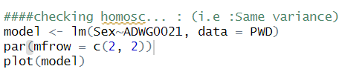

* The code is used to fit a linear regression model to the relationship between ADWG0021 and Sex and create a set of four diagnostic plots of the model to assess the assumptions of the model and identify any potential issues with the model fit or the data.
* **Output:**
* The scatterplot of the fitted values against the dependent variable can help identify patterns in the relationship between the variables, such as linearity or curvature.
* The Q-Q plot of residuals can help assess the normality of the residuals.
* The plot of residuals against the fitted values can help identify heteroscedasticity (unequal variances) or nonlinear relationships.

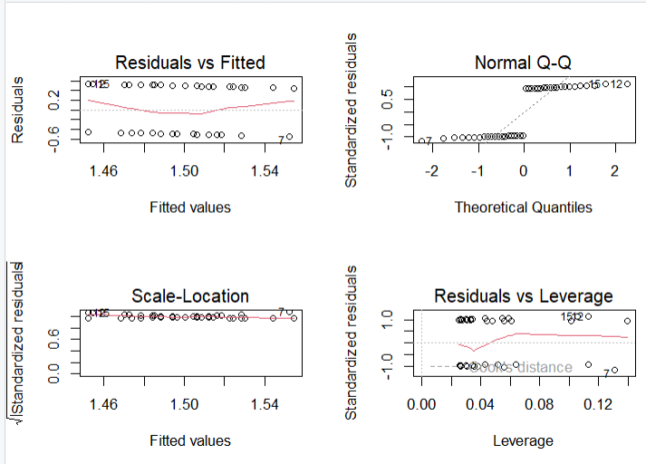

* In Normal Q-Q plot: we can use it to check normality of the data and as shown in the output most of the points are near to form a straight line that’s why the data is normally distributed.
* In Scale-Location: checks the Variance and from the output it indicates that the data is homoscedastic.
* **In Bartlett's test :**
* The null hypothesis (HO) means there is no difference in variance, the alternative (H1) means there is differences in variance (Heteroscedastic).
* From the test results : we can see that p-value equals to 0.4129 which is larger than the significant level alpha(0.05) so we do not have enough evidence to reject the null hypothesis and in support of alternative hypothesis. This concludes that we can assume our data is homoscedastic (they do have the same variance).
* **In var.test:**
* The code:

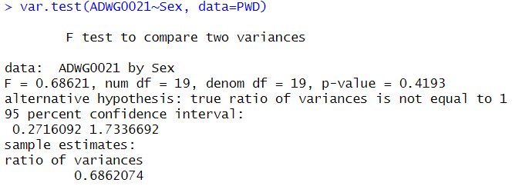

* The output



* using var.test() to test whether the variances of ADWG0021 are equal between males and females in the PWD dataset.
* As p-value = 0.4193 which is greater than alpha(0.05) so we don’t have enough evidence to reject null hypothesis and in support of alternative hypothesis (This concludes that we can assume our data is homoscedastic (they do have the same variance).
* **2nd: We hypothesis that ADWG0021is “different” in the group receiving Treatment A (normal feed + ZnO) compared to the Treatment B (normal feed + nutraceuticals). Can you test this hypothesis assuming hetero****scedasticity , Assess the previous test assumption.**
* **First: We hypothesis that ADWG0021is “different” in the group receiving Treatment A compared to the Treatment B**
* The code:

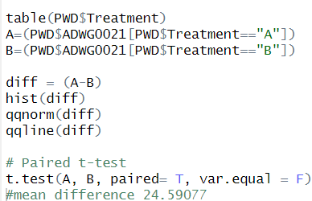

* diff = (A-B), creates a new vector diff that contains the differences between the values of ADWG0021 for the A and B treatment groups. This vector represents the paired differences between the two groups, which will be used in the paired t test.
* Then we applied a two-sided paired t-test on the differences between the A and B treatment groups.
* The t.test() function is used to perform a t-test on two sets of observations.
* The output

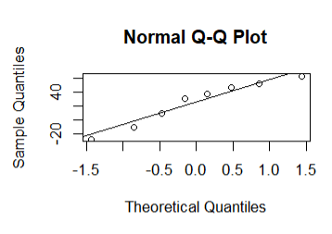

* Most of the points fitted the straight line as shown in the Q-Q plot this shows that there is no difference in variance(Homoscedastic) and the data is normally distributed (it indicates that the differences are normally distributed).

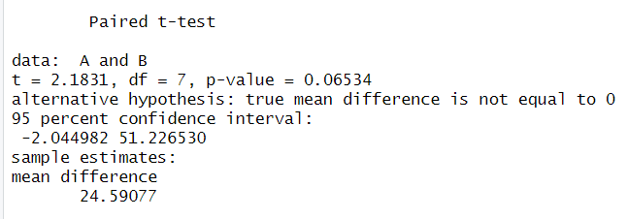

* t-test shows that the value of P-value(0.06534) is greater that alpha value (0.05) so we don’t have enough evidence to reject null hypothesis and in support of alternative hypothesis.
* mean difference is 24.59077 this means that mean difference is not equal to 0 which indicates that there is no significant difference between treatment A and treatment B.
* So, in conclusion after doing t-test and Q-Q plot and we hypothesis that ADWG0021is “different” in the group receiving Treatment A compared to the Treatment B we found that our data is homoscedastic (they have the same variance).
* **C) We hypothesis that ADWG0021is different between the different Treatments . Can you perform comparison between the different groups, after assessing the assumptions and performing post-hoc testing (assuming normality and homoscedasticity).**
* Firstly: ADWG0021is different between the different Treatments perform comparison between the different groups.
* *Levene's test (for homogeneity of variance) :The test is used to assess whether the variances of a continuous variable are equal across different groups or levels of a categorical variable.
* The code:

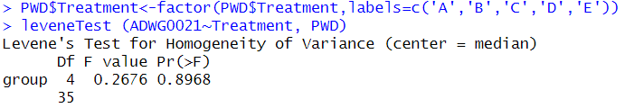

* The output:
* The null hypothesis of Levene's test is that the variances of the groups are equal
* The alternative hypothesis is that at least one of the variances is different from the others.
* Since the result of levene-test is p-value(0.8968) > alpha value(0.05), so we don't have enough evidence to reject the null hypothesis and they have same variance , therefore we can state that they are homoscedastic. as there is not enough evidence to prove that the variances of the ADWG0021 values are different across the five treatment groups.
* The code:

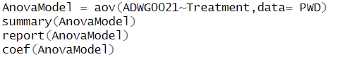

* Anova test is a statistical formula used to compare variances across the means (or average) of different groups.
* The aov() function is used to fit an ANOVA model.
* Anova Model produces a summary of the ANOVA model.
* Output of anova test :

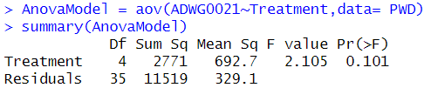

* The summary() function is used to display a summary of the ANOVA model which includes the degrees of freedom, the sums of squares, the mean squares, the F-statistic, and the p-value and this information help us to assess the significance of the relationship between ADWG0021 and Treatment.

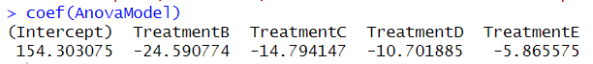

* The coef() function is used to extract the coefficients of the model, which include the intercept and slope coefficients for each level of the categorical variable Treatment.
* Since the result of anova test is p-value(0.101) > alpha value(0.05) so, we don't have enough evidence to reject the null hypothesis this indicates that they have same variance , therefore we can state that they are homoscedastic.
* **Performing post-hoc testing (assuming normality and homoscedasticity).**
* Post-hoc testing is a statistical procedure that is used to make pairwise comparisons between groups after an overall ANOVA or regression analysis has been performed, in order to determine which specific groups, differ significantly from each other.
* The code:

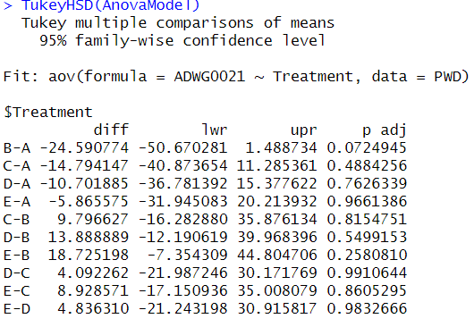

* The output:
* The output of the TukeyHSD() function display a table of comparisons between each pair of levels of Treatment, along with the difference between the means, the standard error, the p-value, and the 95% confidence interval for the difference.
* * But post-hoc tests can increase the chance of making a Type I error (rejecting the null hypothesis when it is true).

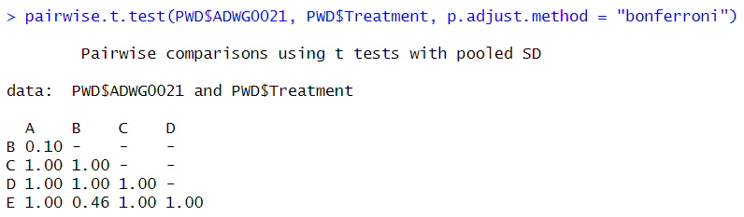

* Next, we used the **Bonferroni correction method to account for multiple comparisons**
* The output of the pairwise.t.test() function would display a table of comparisons between each pair of levels of Treatment, along with the difference between the means, the t-statistic, the degrees of freedom, the p-value, and the adjusted p-value (after applying the Bonferroni correction).
* It is important to note that the pairwise t-test with Bonferroni adjustment is a conservative approach, which increases the chance of making a Type II error especially when the sample size is small, or the variances are unequal.
* The table indicates which pairs of levels are significantly different from each other based on p-values.
* **We also used dunn.test()**
* To perform pairwise comparisons between groups using rank-based nonparametric tests, such as the Dunn's test or the Bonferroni correction. The function is commonly used as a post-hoc test after performing a non-parametric analysis of variance (ANOVA), such as the Kruskal-Walli’s test.
* The code:



* The output:

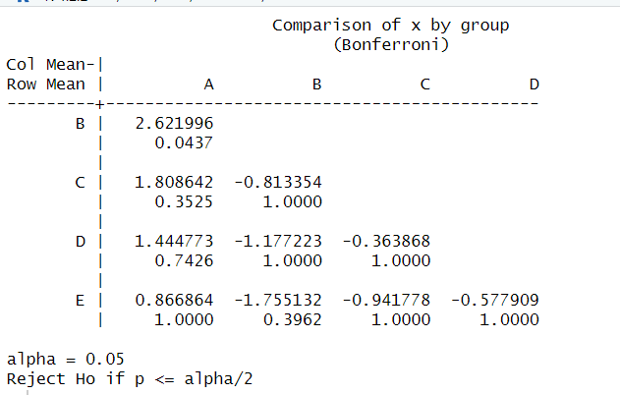

* In each set of treatments, this is a linear hypothesis. With a p-value for B-A treatments of 0.0437, which is less than 0.05, we have sufficient data to rule out the null hypothesis that the data are not normal and that B-A treatments differ in ADWG0021.
* Linear Model
* **1)Fit a linear regression to the data and interpret the regression coefficient (for the one of the hypotheses mentioned above)**
* First, we plot the data, then we create our regression model to match the regression line, and finally, we test and compare the results with the null hypothesis that slope equals zero (y cannot be predicted by x) and the alternative hypothesis that slope differs from zero (y can be predicted by x).
* Because linear regression is continuous (ADWG0021) with categorical (sex), convert it to numeric and assume male=2, female=1, then plot and get intercept and slope; #coefficients a and b (intercept = 144.07 and slope = -1.92), this means that the intercept is a predicted value of Y when X is zero (unit is the same as in Y), and the slope is the rate of change in y (age) as x changes.
* The null hypothesis is that the slope equal zero
* Alternative hypothesis is that the slope is not equal to zero
* The code:

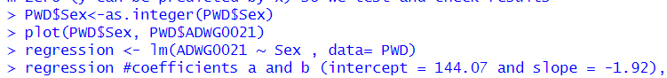

* The output:

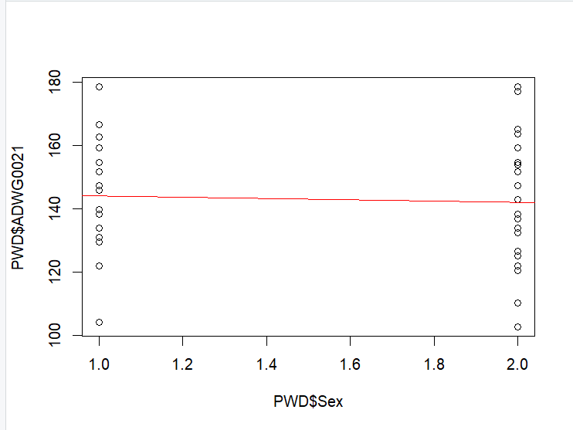

* It is obvious that there is no linear relationship between the explanatory variable sex with the response variable ADWG0021 as the sex is categorical as shown in the figure. and ADVG0021 is continuous so the regression line is horizontal seems to be zero so it means that y (ADWG0021) can't be predicted by x (sex) as there is no linearity between them.
* As sex is categorical, there is no linear relationship between the explanatory variable sex and the response variable ADWG0021, as seen in the output. Because ADVG0021 is continuous, the regression line seems to be horizontal, implying that y (ADWG0021) cannot be predicted by x (sex) because there is no linearity between them.

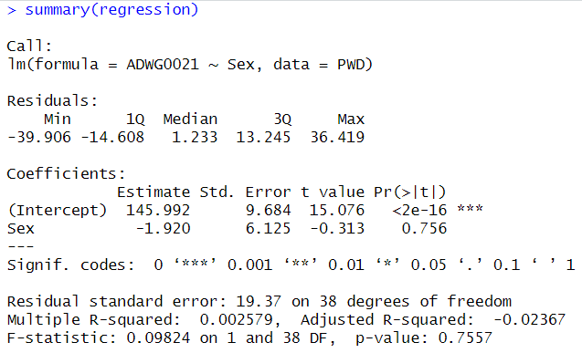

* Coefficients a and b (intercept = 144.07 and slope = -1.92), therefore that the intercept is a predicted value of Y when X is zero (unit is the same as in Y), while the slope is the rate of change in y (age) as x changes.
* The results of regression models
* The residuals result is too bad, which is 1.23, indicating that the error is too large, and the p value is 0.756, which is much greater than the significance level of 0.05, indicating that we do not have enough evidence to reject the null hypothesis, so the slope is equal to zero, indicating that y cannot be predicted by x (there is no linear relationship between the response variable and the explanatory variable), and the residual standard error (mean square error) is 19.37, which is too large which is not good and f value is too small 0.09824 which results in the large p value and finally the adjusted R squares is too small -0.02367 which is a not good at all(it explains -0.02 from the variability of y).
* **2)Calculate and interpret a 95% confidence interval of the regression slope.**
* Confidence interval is with the regression model and x axis.
* The code:



* Here, we are 95 percent confident that the true population mean lies in the sampling distribution of sample means between 2.5% (-14.31805) and 97.5% (10.47877).
* This indicates that we don’t have enough evidence to reject the null hypothesis(slope equals zero) (no linearity and y cannot be predicted by x), this shows that ADWG0021 cannot be predicted by sex.

**Other variables, linear regression but 2 continuous variables**

* The code:

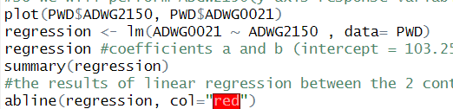

* ADGW2150 (y axis response variable) with ADWG0021 (x axis explanatory variable).
* coefficients a and b (intercept = 103.25181 and slope = 0.07958), therefore that the intercept is a predicted value of Y when X is zero (unit is the same as in Y), while the slope is the rate of change in y (age) as x changes.
* The Output:

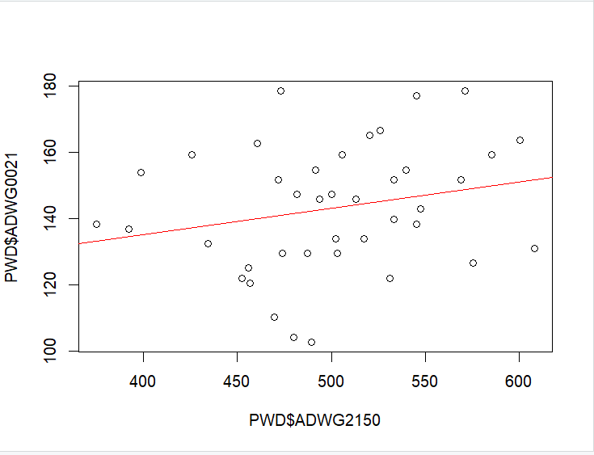

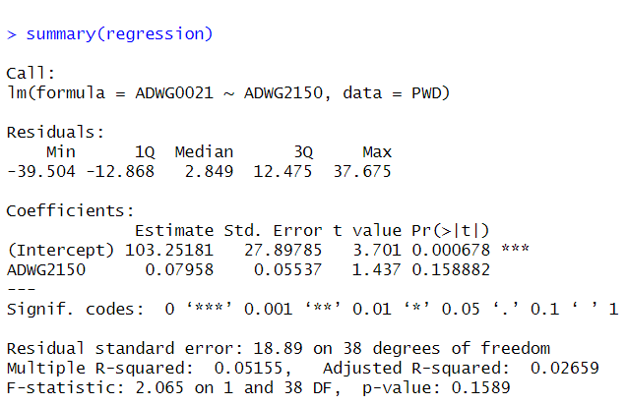

* The results of linear regression between the two continuous variables ADWG0021(y) and ADWG2150(x) give a poor model because the residuals median is too large (2.849) and the p values is equal to 0.158882, which is much greater than 0.05, so we do not have enough evidence to reject the null hypothesis. Accordingly, y(ADWG0021) cannot be predicted by x(ADWG2150) because there is no linearity between them. Additionally, the adjusted R squared is more accurate than the R squared, and the adjusted gives a very small value, which is 0.02659 (2.5%), meaning that the regression model only explains (captures) 2.5% of the total variation of y(ADGW0021), which is not good at all. Therefore, there is no linearity between them.
* **C) Calculate and interpret a 95% confidence interval of the regression slope.**
* The code:



* Here, we have a 95% confident that the true population mean lies in the range of 2.5% (-0.03252242) and 97.5% (0.191674) of the sample mean distribution.
* This indicates that we don’t have enough evidence to reject the null hypothesis( the slope equals zero) (no linearity and y cannot be predicted by x), it is showed that ADWG0021 cannot be predicted by sex.
* However, since the confidence interval for the coefficient of Sex Male includes zero; we cannot conclude with 95% confidence that there is a statistically significant difference in the average value of ADWG0021 between males and females.
* **3)Estimating the average ADWG0021 change for with changing the gender from 1 to 2 .**
* To determine if sex has an effect or not, we will now run multiple linear regressions with the two continuous variables ADGW0021 and ADGW2150. The model will be constructed by graphing the response variable (ADWG0021) against the two explanatory factors (sex+ADWG2150). #coefficients, where the intercept is the expected value of Y when X is zero (the unit is the same as in Y), and the slope is the rate of change in Y (age) as X changes (intercept = 102.97717 and slope of ADWG2150= 0.07981, slope of Sex = 0.10592).
* So that’s why the intercept is a predicted value of Y when X is zero (unit is the same as in Y), while the slope is the rate of change in y (age) as x changes.
* The code:

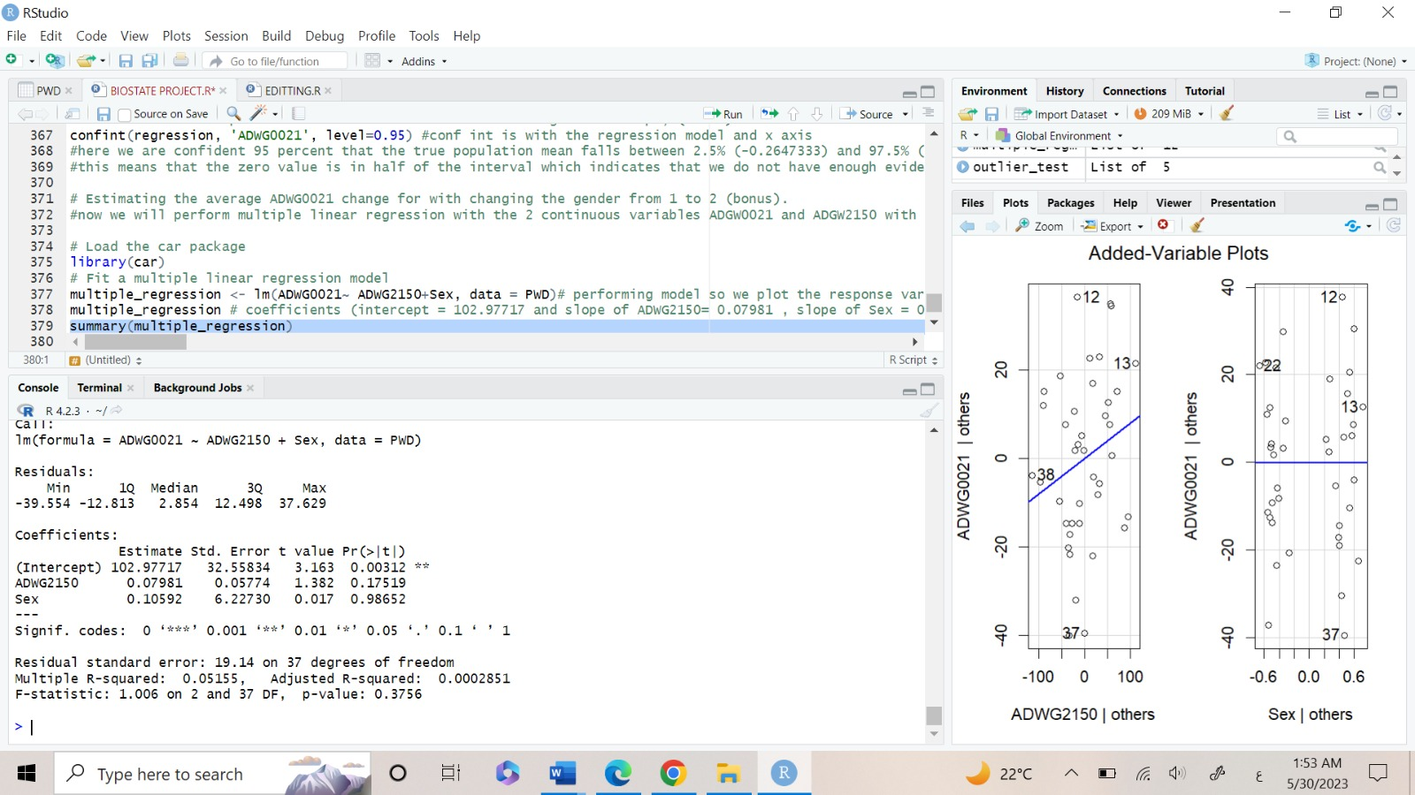

* The output:

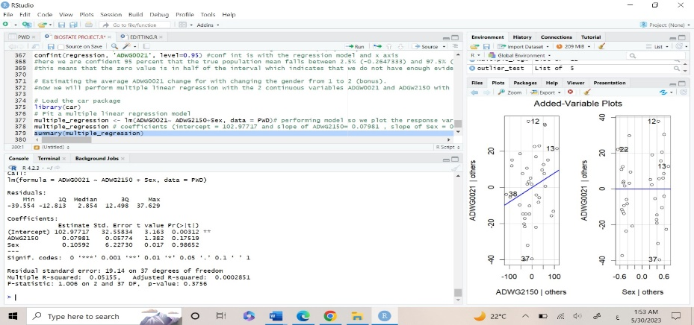

* The results of multiple linear regression between the three variables ADWG0021(y), ADWG2150+Sex, and the residuals median are also unfavorable (2.854), and we lack sufficient evidence to reject the null hypothesis because y(ADWG0021) cannot be predicted by x(ADWG2150) in the presence of Sex because there is no linearity between them and p value of sex is equal to 0.98652, which is also higher than 0.05. when fitted shows that it is horizontally so that means that the slope is close to zero (null hypothesis).
* Also, the adjusted R squared is more accurate than the R squared and the adjusted gives a very small value which is 0.0002851(0.02%) which means that the regression model explains(capture) only 0.02% of the total variation of y(ADGW2150) which is not good at all, so there is no linearity.
* **In conclusion:**
* Finally, we discovered that treatments A and B significantly differed from the other treatments, indicating that they had an impact on the piglets. As a result, y cannot be predicted by x because there is no linear relationship between ADWG0021 and ADWG2150 or between ADWG0021 and Sex (x). The multiple linear regression showed that the presence of sex had no bearing on the two continuous variables ADWG0021 and ADWG2150.
* **Contribution table:**

|  |  |
| --- | --- |
| Name | Points |
| Sarah Elmaasarawii | Last 2 points in point 2, point3 and 6 with youmna |
| Youmna Tarek | Point 1 and first 3 points in 2 and 6 with sara |
| Merna Salem | Points 4 and 5 |
| Mohamed Elteweay | Point 7 |